Developed by Shaun Owens

Whizzy Software

Media Organiser

User Guide

Table of Contents

Purpose of the Media Organiser 2

Main Screen 3

Data Buttons 4

Save Data 5

Load Data 5

Clean Media Organiser 5

Add Artist Page 6

Show Artist 7

Edit Artist 8

Edit the Artist 8

Delete the Artist 8

Add Album 9

Show Album 12

Edit Album 13

Edit the Album 13

Delete the Album 13

Show Song 14

Playlists 16

Add Playlist 17

Show Playlist 18

Edit Playlist 19

Edit the Playlist 19

Delete the Playlist 19

Categories 20

Developer Notes 22

Transferring into other Laravel projects 22

Database Migrations 23

Other things to consider 23

# Purpose of the Media Organiser

The Media Organiser has been created to add, read, edit and delete songs, albums and artists as well as organising them to make the home page more readable to the user.

The Media Organiser works effectively across all computers and devices and this user guide is applicable to whichever you use.

The Media Organiser interconnects its data, meaning it has constraints:

* An album cannot be made without an artist;
* When an album is deleted, the songs associated with the album are deleted too;
* When an artist is deleted, the albums and songs associated with the artist are also deleted.

Categories can be amended also, meaning you can add a new category as well as changing the category name or deleting the category.

The Media Organiser has been developed using the Laravel Framework which primarily uses PHP along with other standard web languages. Details on how to implement the Media Organiser into your own Laravel Project can be found in Annex D at the end of the document.

If you encounter a problem with the Media Organiser please contact Whizzy Software Support at support@whizzysoftware.com.

# Main Screen

This is the initial view that the user will see when opening up the Media Organiser. If there is a screen that says ‘Run Migrations’, skip to the end of this document and run the table migrations to the database.

If there are no entries there is a clear message that an entry needs to be made and a button that opens up the ‘Add Artist’ page.

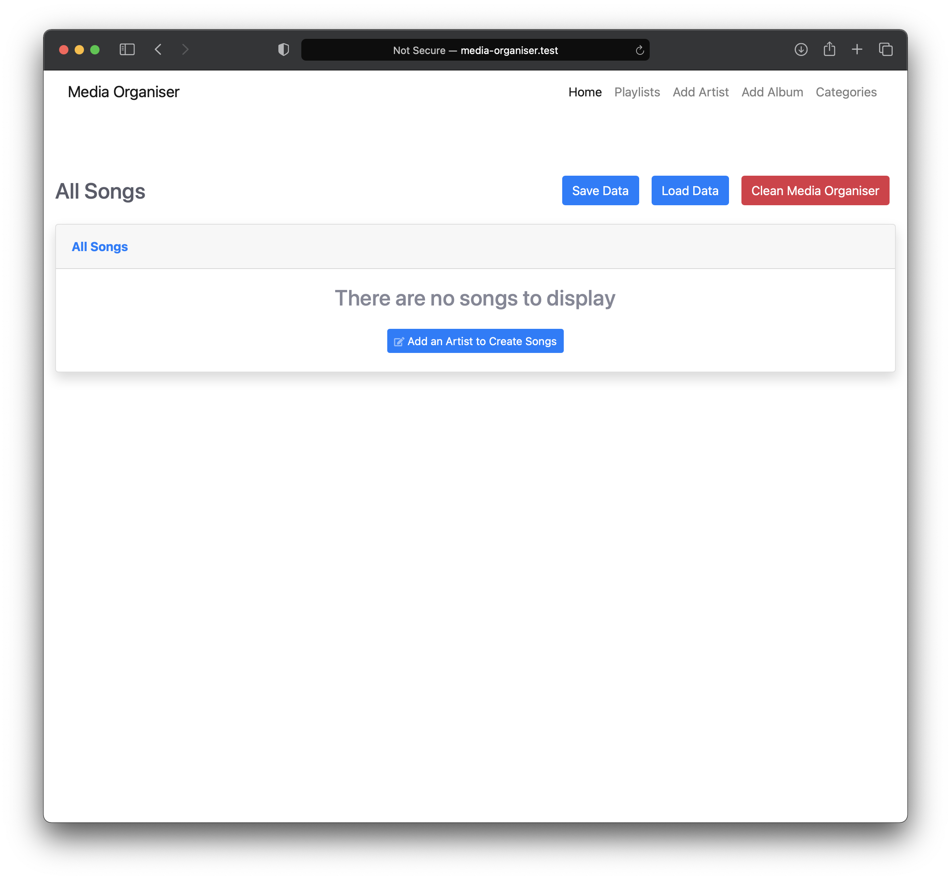

If there is data already stored on the database, all the songs will be listed in the displayed table. The table has many features, these are:

* Search for a song, artist, album or category within the table;
* In the ‘Show’ dropdown you can select how many songs are to be displayed on the table;
* Clicking on the column header organises the table in ascending or descending order;
* At the bottom of the table you can navigate through the songs, the more songs there are, the move page numbers appear.

To view a song, simply click on the song row in the table, this will open up the ‘show-song’ page where you can listen to the song and view other details of the song.

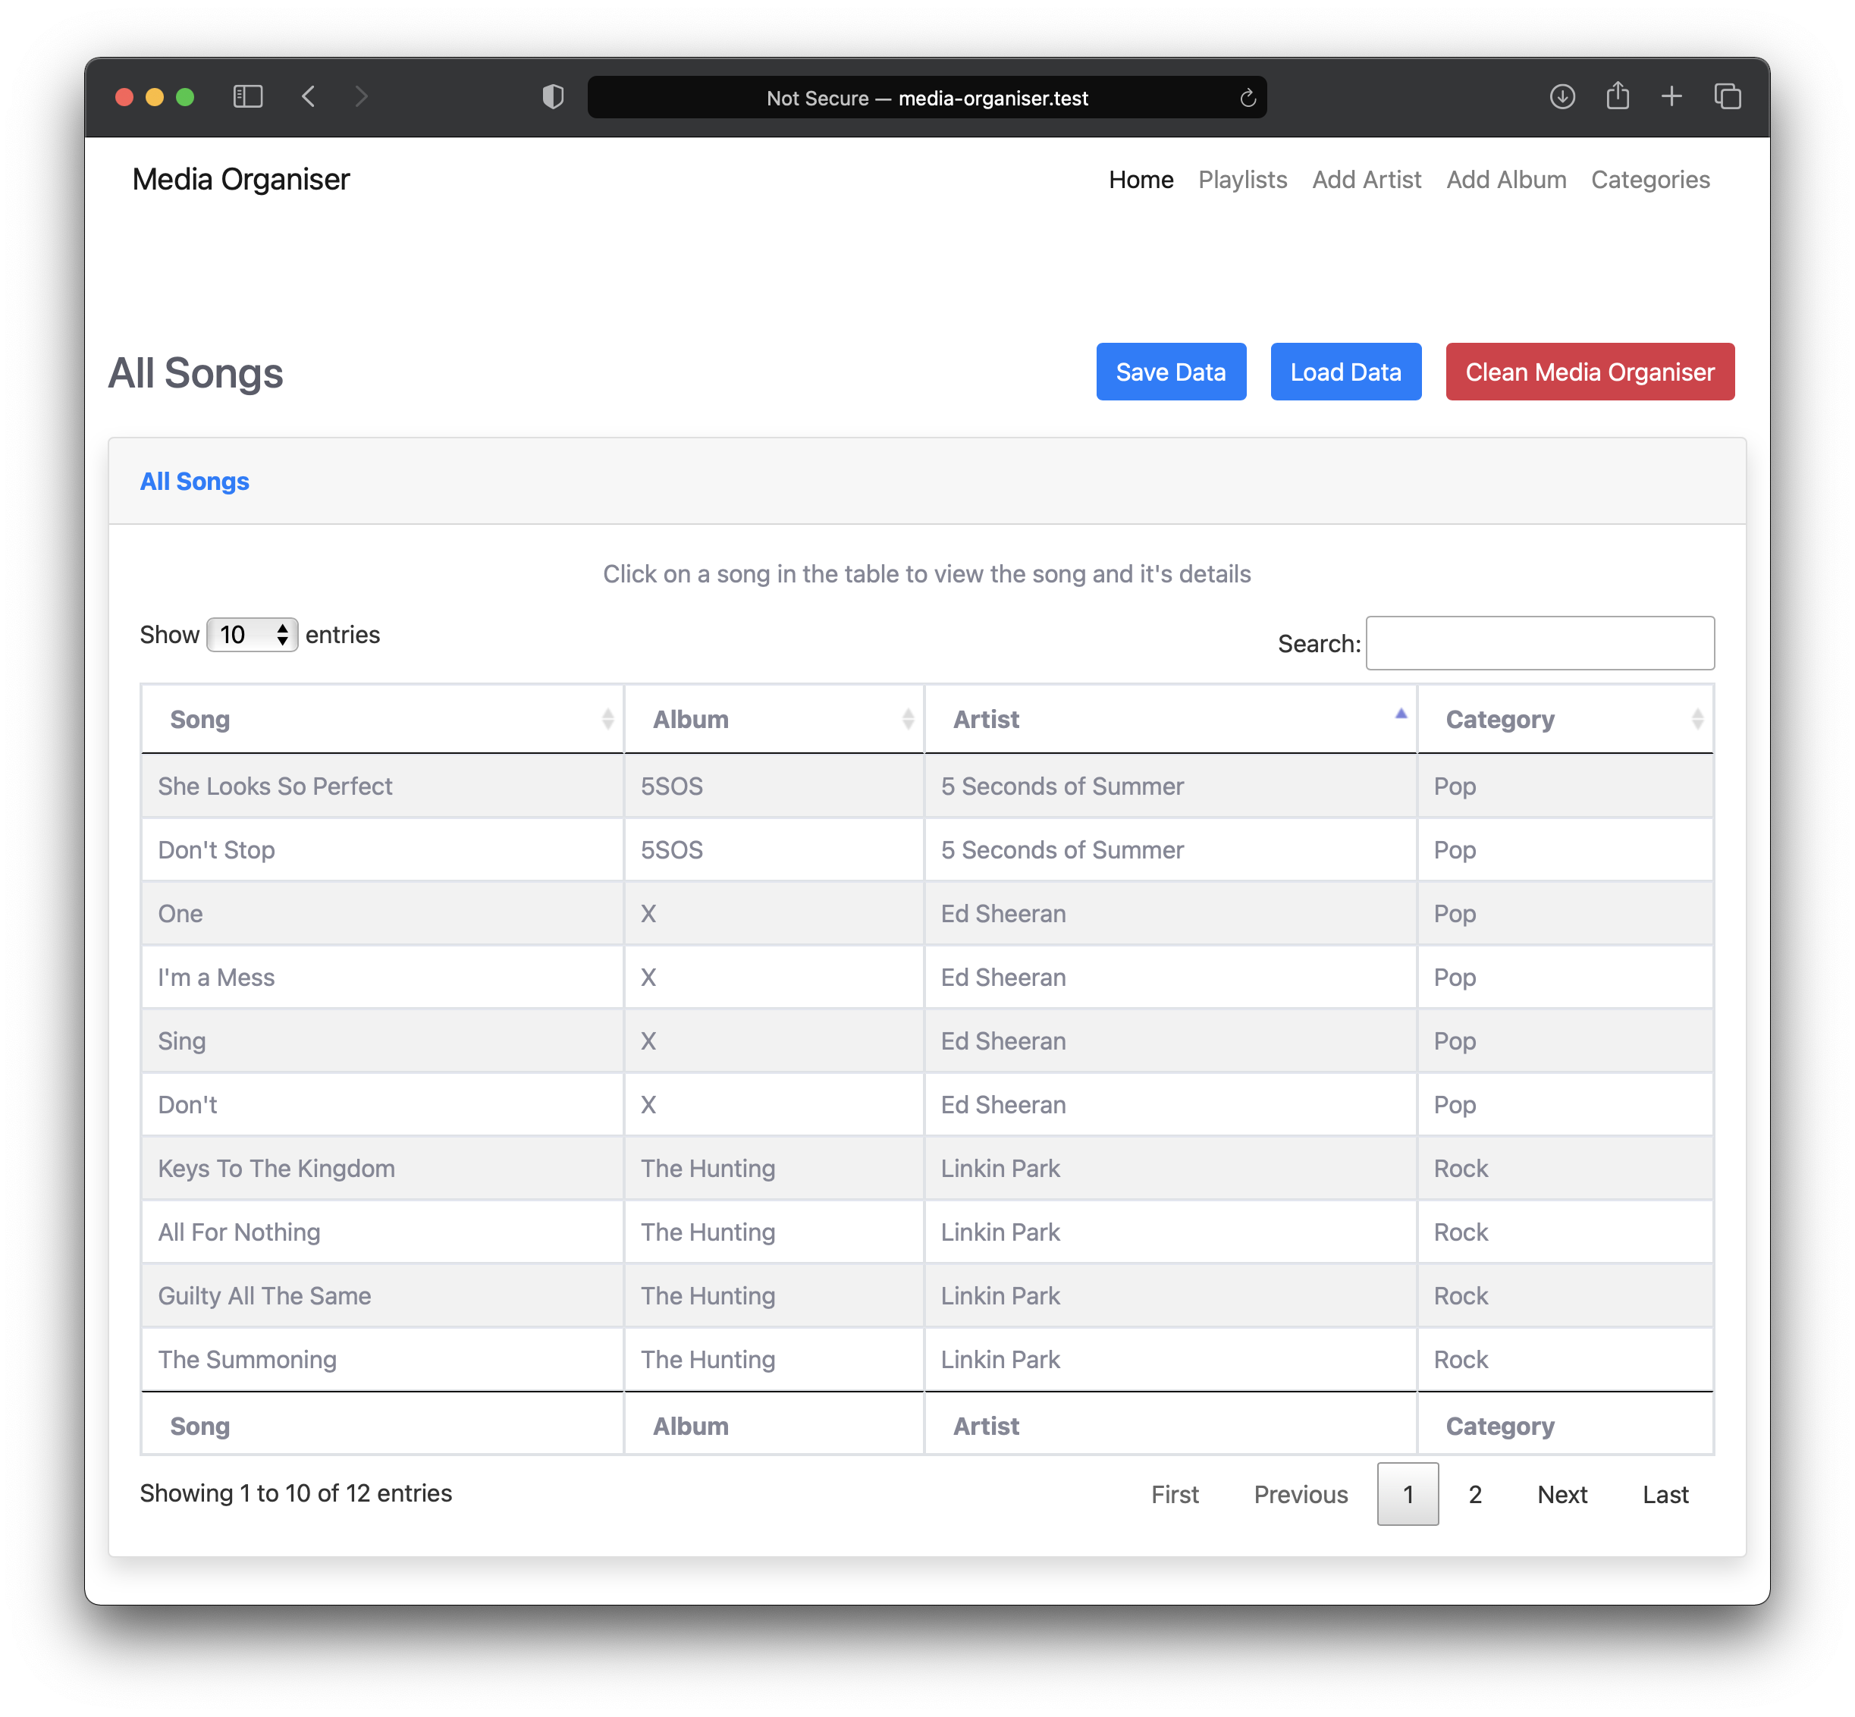

## Data Buttons

There are three ‘Buttons’ located above the table.

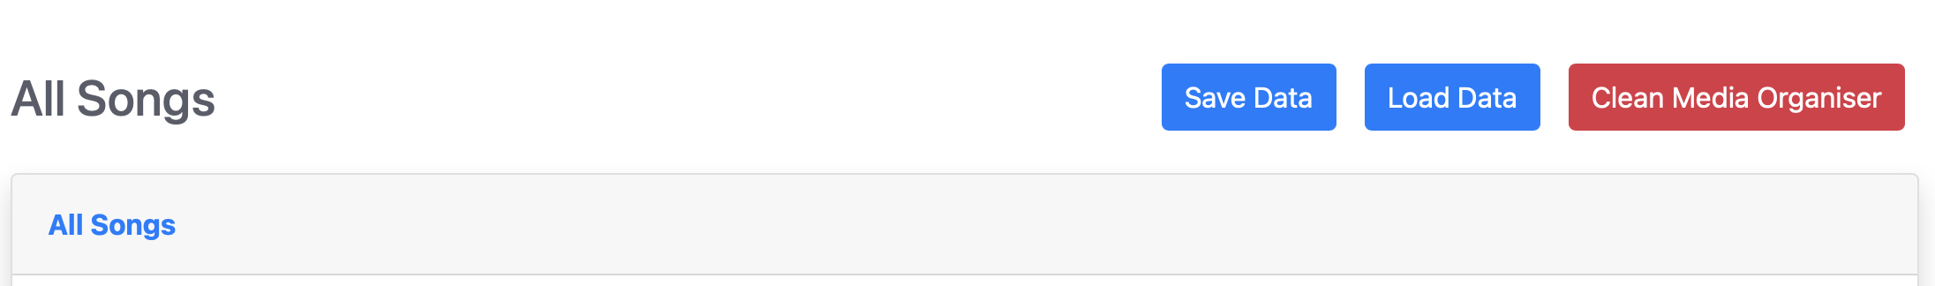

Each button has a different function and affect the way the Media Organiser works, please take note of each button function.

### Save Data

This button saves all of the data on the database to a local file (.csv). Each time the ‘Save Data’ button is clicked, the previous local file is overwritten.

### Load Data

This button clears the database and loads the local file (.csv) data into the relevant tables. The data is cleared first as some tables rely on information in some of the other tables and loading on top of previous data can cause duplicate entries to appear and may affect the functionality of the Media Organiser.

### Clean Media Organiser

This Button will clean all the stored data in the Media Organiser including the database. This includes the stored images, songs and table information in each database, this cannot be undone. When clicking the button a prompt will appear asking if you are sure you want to proceed.

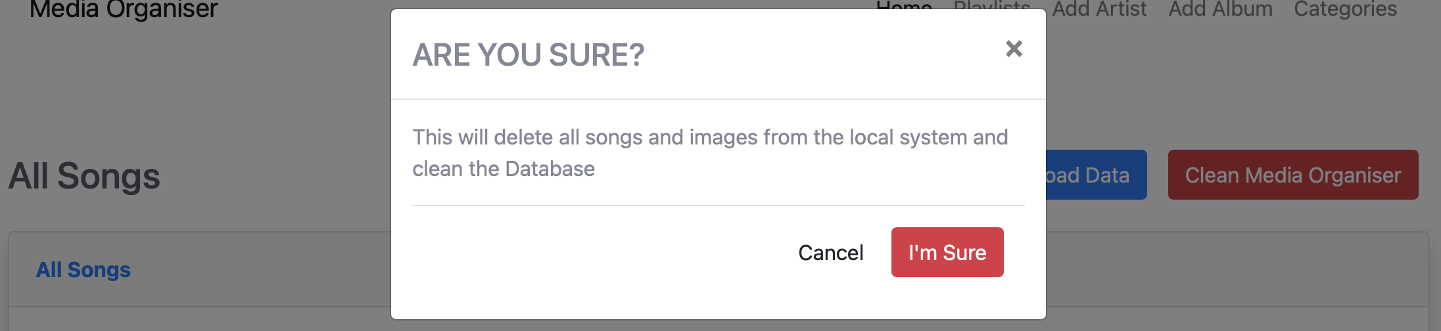

# Add Artist Page

On this page you can create a new Artist.

Fill in the Artist Name and a Description within the input boxes and click the ‘Save Artist’ button.

The Artist Name input is a mandatory input whereas the Description input is not mandatory.

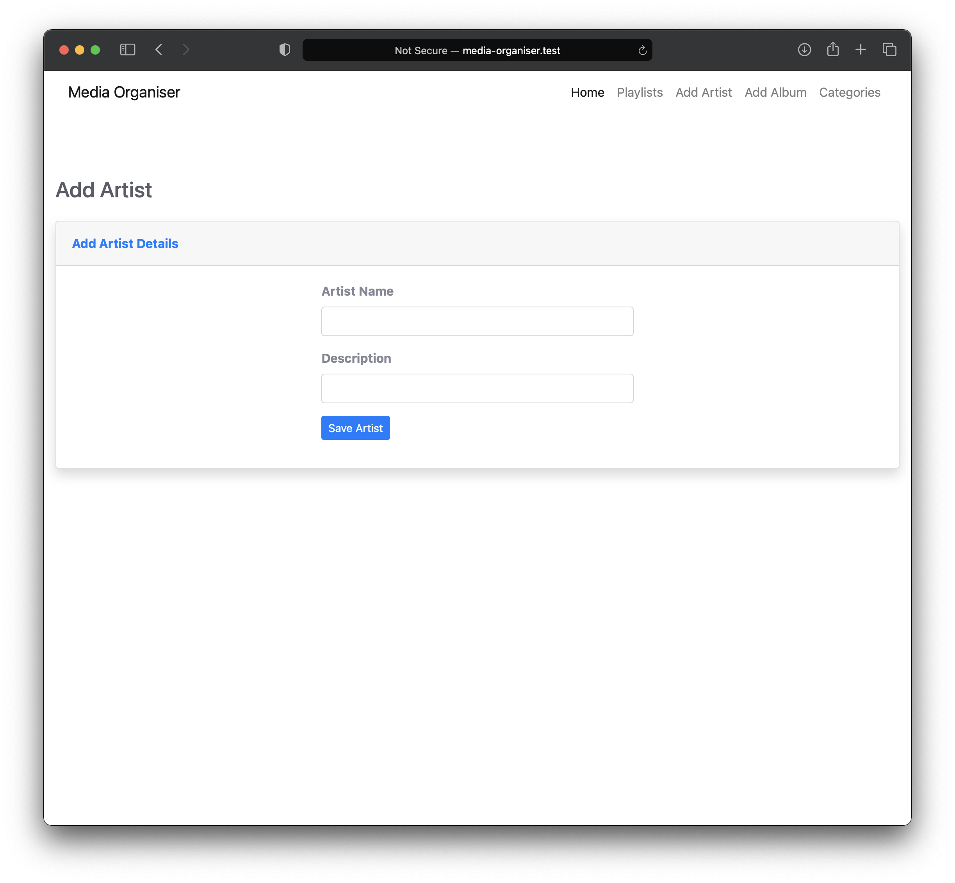

# Show Artist

This page shows the Artist that you have created.

The Artist Name is displayed with 2 leading buttons to either edit the selected Artist or add a new Album.

As well as the Artist details, you can view the Albums that are associated with the Artist. To open up one of the Albums, just click the album name and you will open up the ‘show-album’ page where you can view the selected Album’s details.

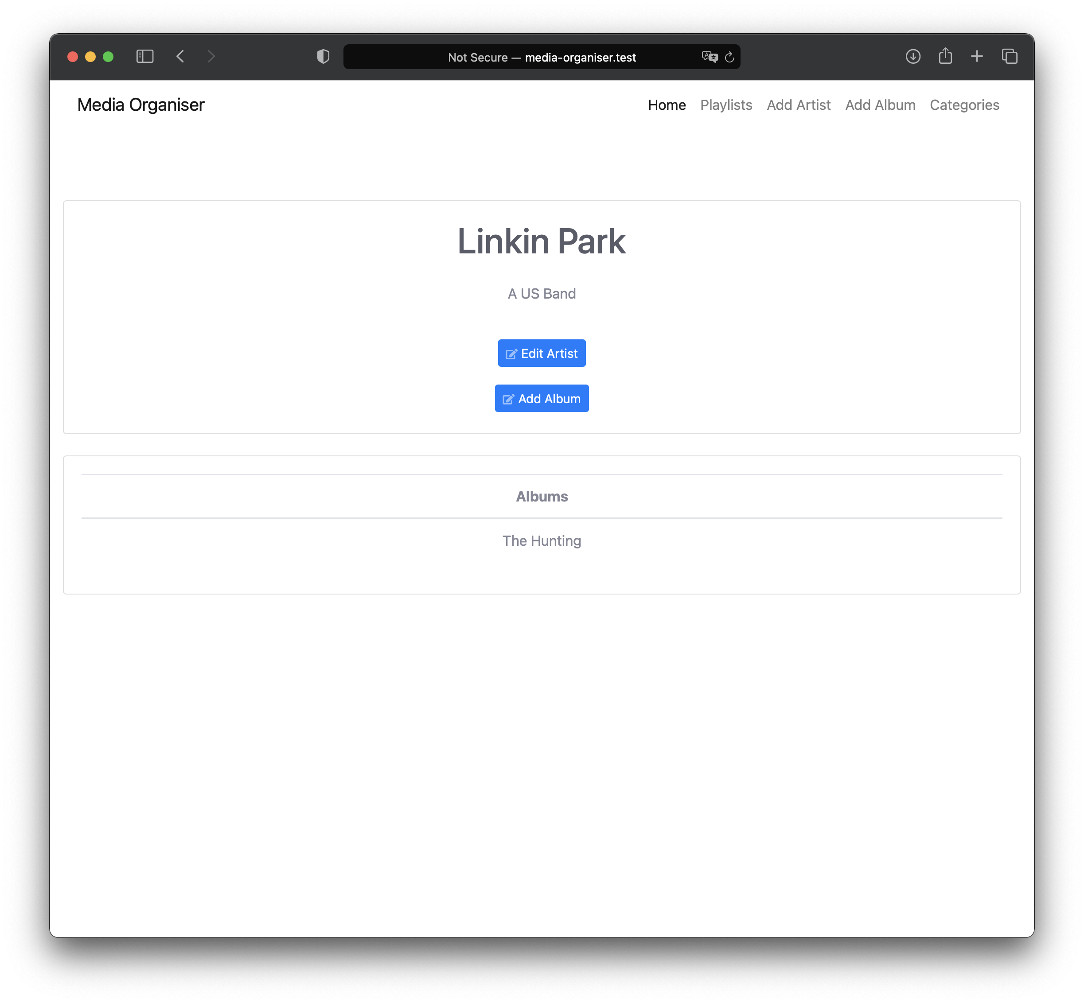

# Edit Artist

When selecting the ‘Edit Artist’ button on the ‘show-artist’ page you will be redirected to the ‘edit-artist’ page.

## Edit the Artist

The Artist Name and the Description will be displayed in the input boxes, you can either edit the inputs or leave them as they are, when you have made your amendments click the ‘Save Artist’ button to save the changes and be sent back to the ‘show-artist’ page.

## Delete the Artist

If you want to delete the selected Artist click the ‘Delete Artist’ button. This will delete the Artist as well as the Artist’s associated Albums. This cannot be undone once deleted.

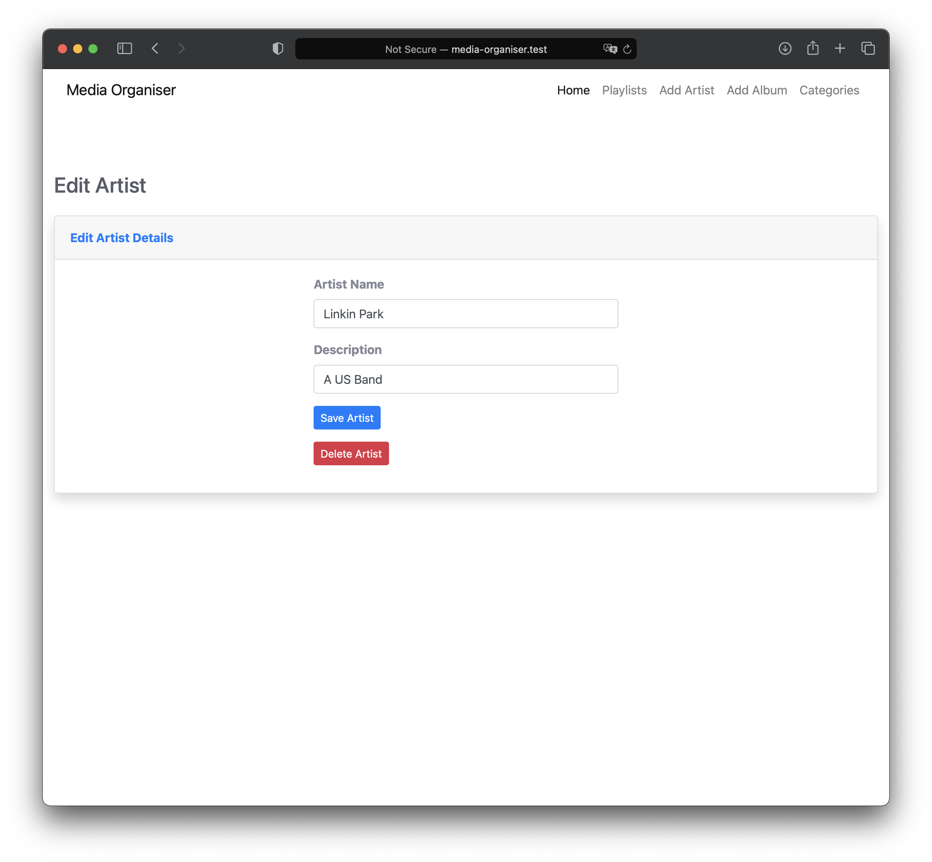

# Add Album

This page is where you can add a new album.

If there are no Artists saved then a message will be displayed saying that there are no Artists and you need to create one, below the message is an ‘Add Artist’ button, alternatively you can click the ‘Add Artist’ link in the navigation bar at the top of the page.

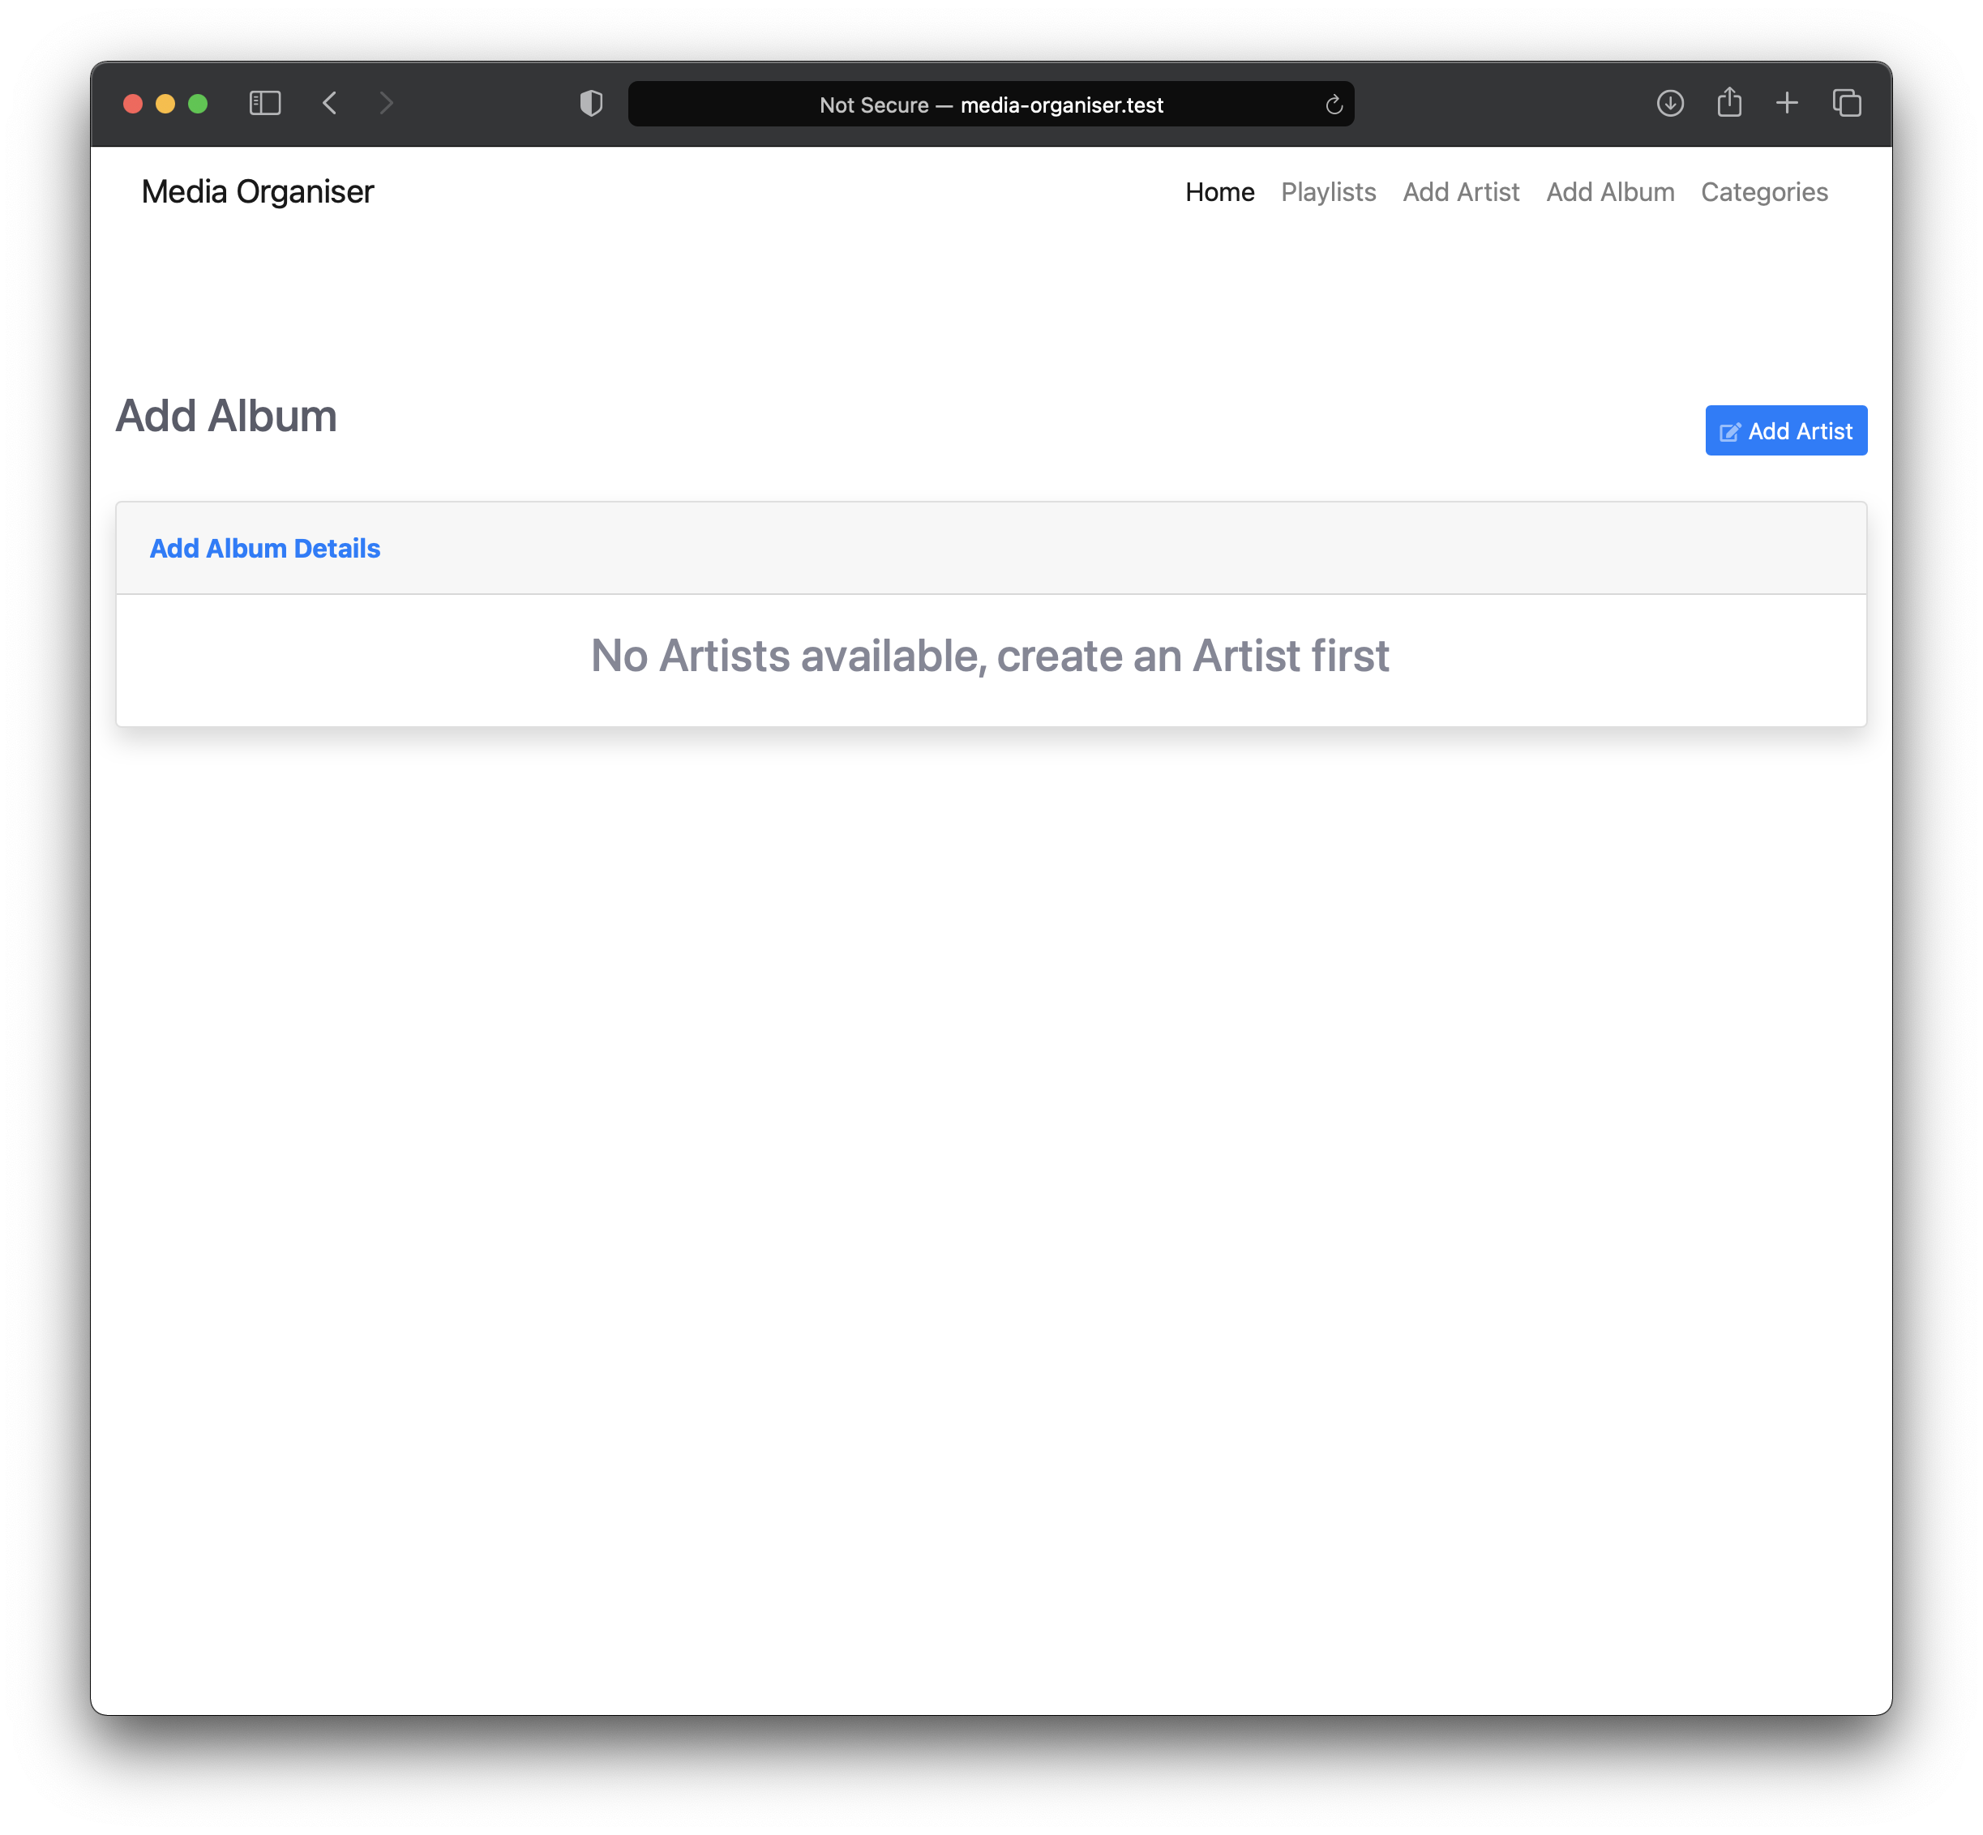

If there are Artists created already you will be presented with form that allows you to create a new Album.

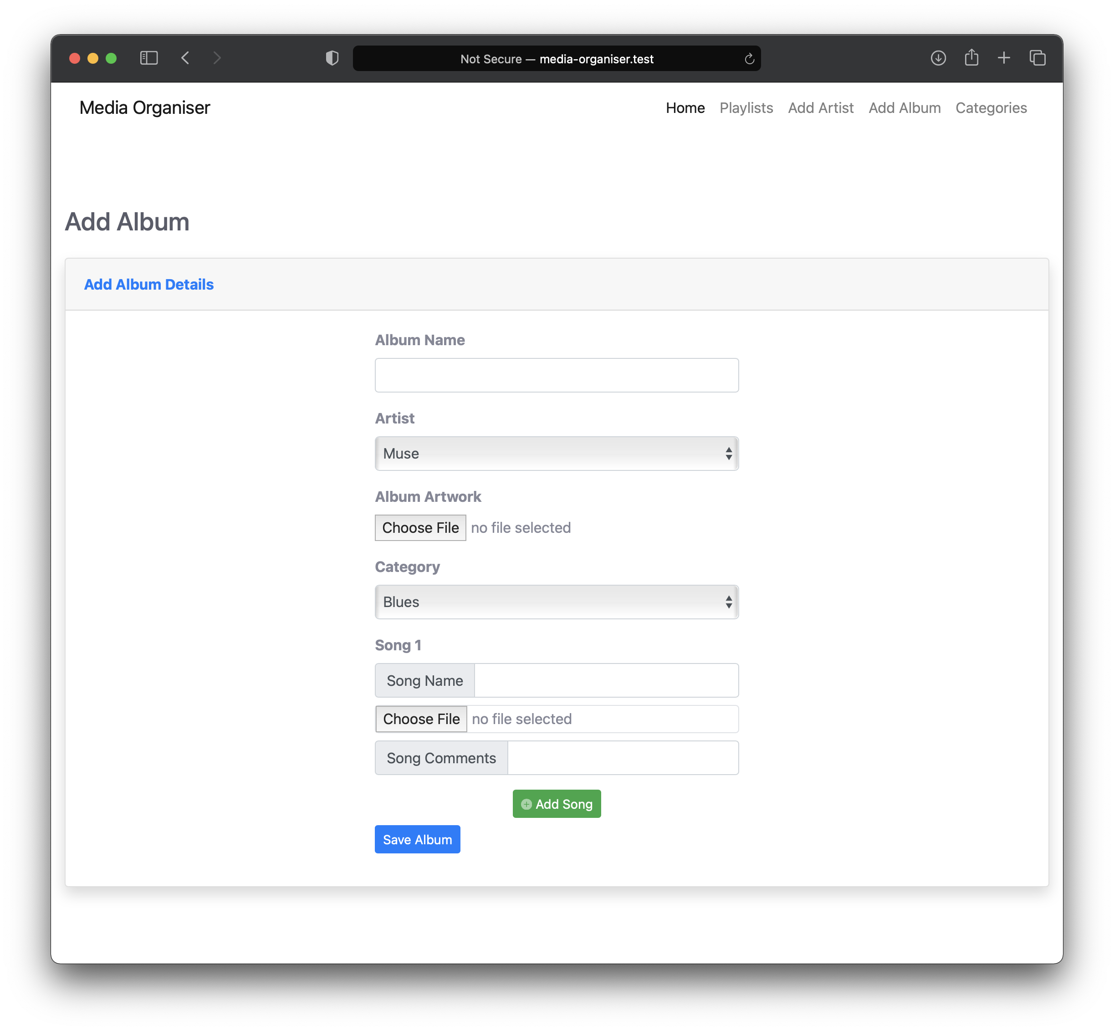

All fields are mandatory apart from the ‘Album Artwork’ input and the ‘Song Comments’ input.

When clicking the ‘Artist’ input it will dropdown and show the Artists that have been created, click one of these to select the Artist who the Album belongs to.

The ‘Album Artwork’ input accepts images, click on the ‘Choose File’ button and upload an image. The input will accept either a .jpg/jpeg or a .png formatted image. If an image is not uploaded the image will default to a beamed quaver image.

The ‘Category’ input when clicked will show a dropdown of all the available categories, these can be amended in the ‘Categories’ page which this User Guide will cover further in. Click on a Category that the Album categorises to.

You can upload a single Song or multiple Songs for the Album. First click the ‘Song Name’ input and insert the name of the Song.

Next click on the ‘Choose File’ button to select a Song file, the file must be in a .mp3 or a .ogg formatted audio file. You do not need to rename the file before uploading to make it relevant to the name of the song, the Media Organiser will rename this in the background for you.

If you have any comments for the Song then these can be inserted into the ‘Song Comments’ input, this is not necessary though if you have not got a comment for the Song.

If you have more Songs to upload then click the ‘Add Song’ button. This will add a new Song section to fill in, there is no maximum amount of Songs you can have but there must be at least one Song.

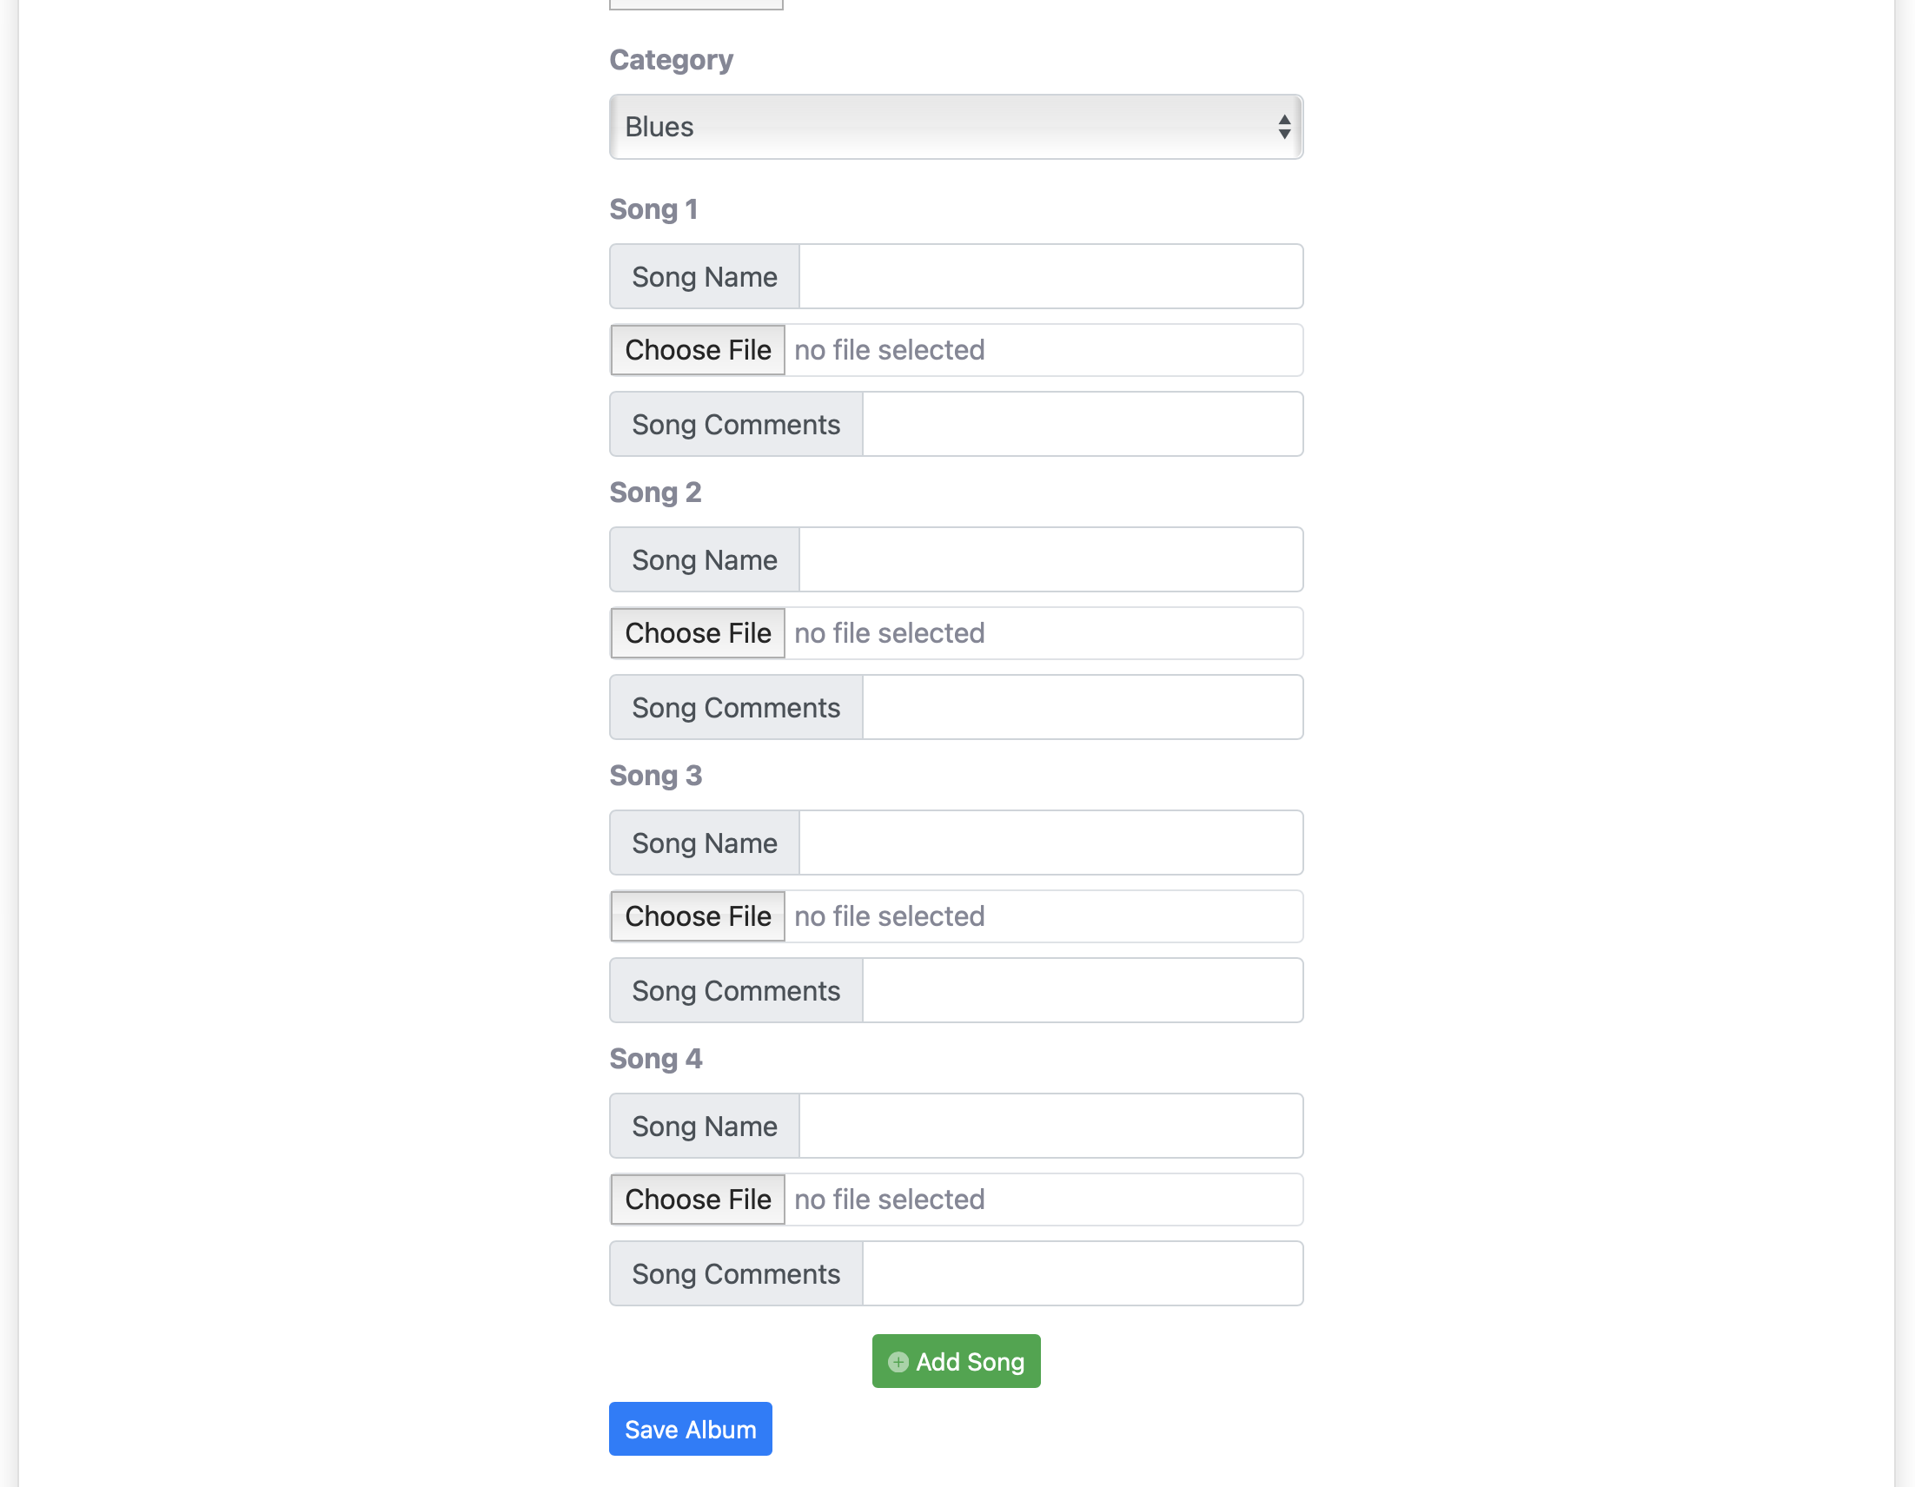

When you have finished filling in the details for the Album click on the ‘Save Album’ button to save the Album and be directed to the ‘show-album’ page.

# Show Album

Here you will be able to see the selected Album.

An image of the Album artwork is displayed with the Album name and the Artist name underneath, to view the Artist just click on the Artist name which will redirect you to the ‘show-artist’ page where you can view the Artist details. Underneath the Artist name is a ‘Edit Album’ button where you can make amendments to the selected Album.

The Category is displayed for the Album and also a list of all the Songs on the Album, select a Song name to view the Song and the Song’s details.

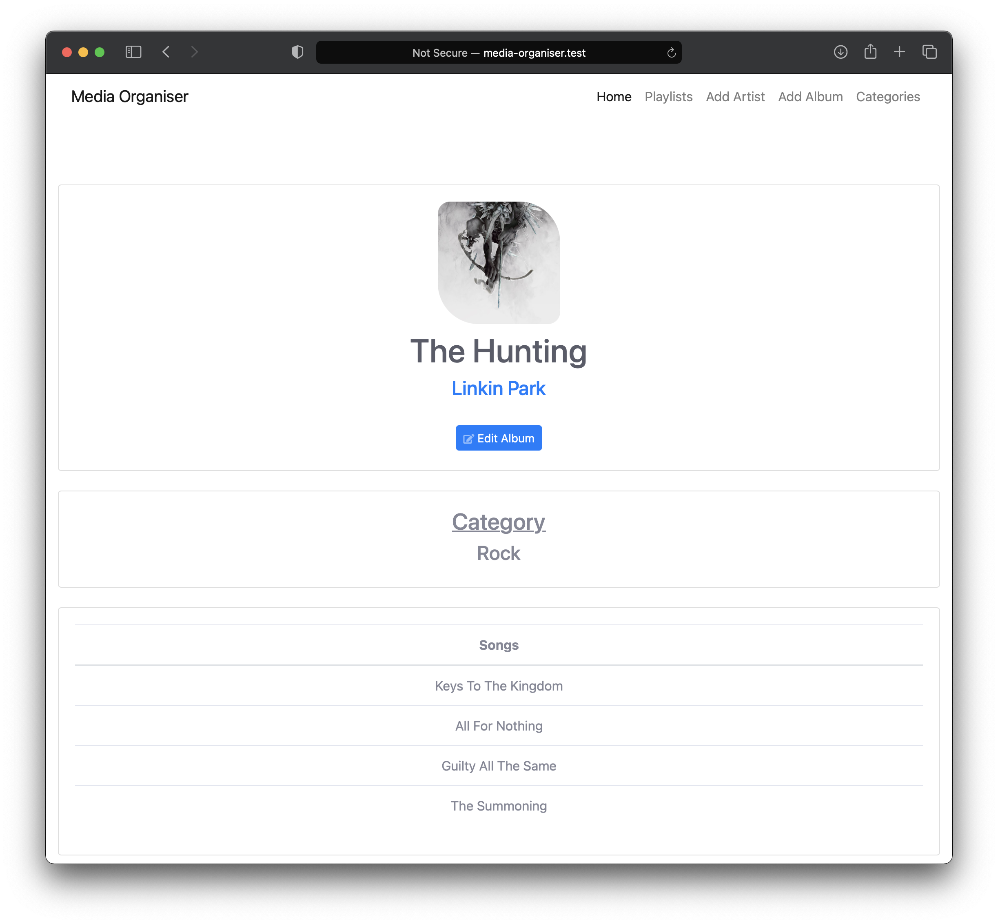

# Edit Album

When selecting the ‘Edit Album’ button on the ‘show-album’ page you will be redirected to the ‘edit-album’ page.

## Edit the Album

The Album Name, Artist, Album Artwork (if any), Category and Songs will be displayed in the input boxes, you can either edit the inputs or leave them as they are, when you have made your amendments click the ‘Save Album’ button to save the changes and be sent back to the ‘show-artist’ page.

The Songs cannot be amended that are associated with the album.

## Delete the Album

If you want to delete the selected Album click the ‘Delete Album’ button. This will delete the Album as well as the Album’s associated Songs. This cannot be undone once deleted.

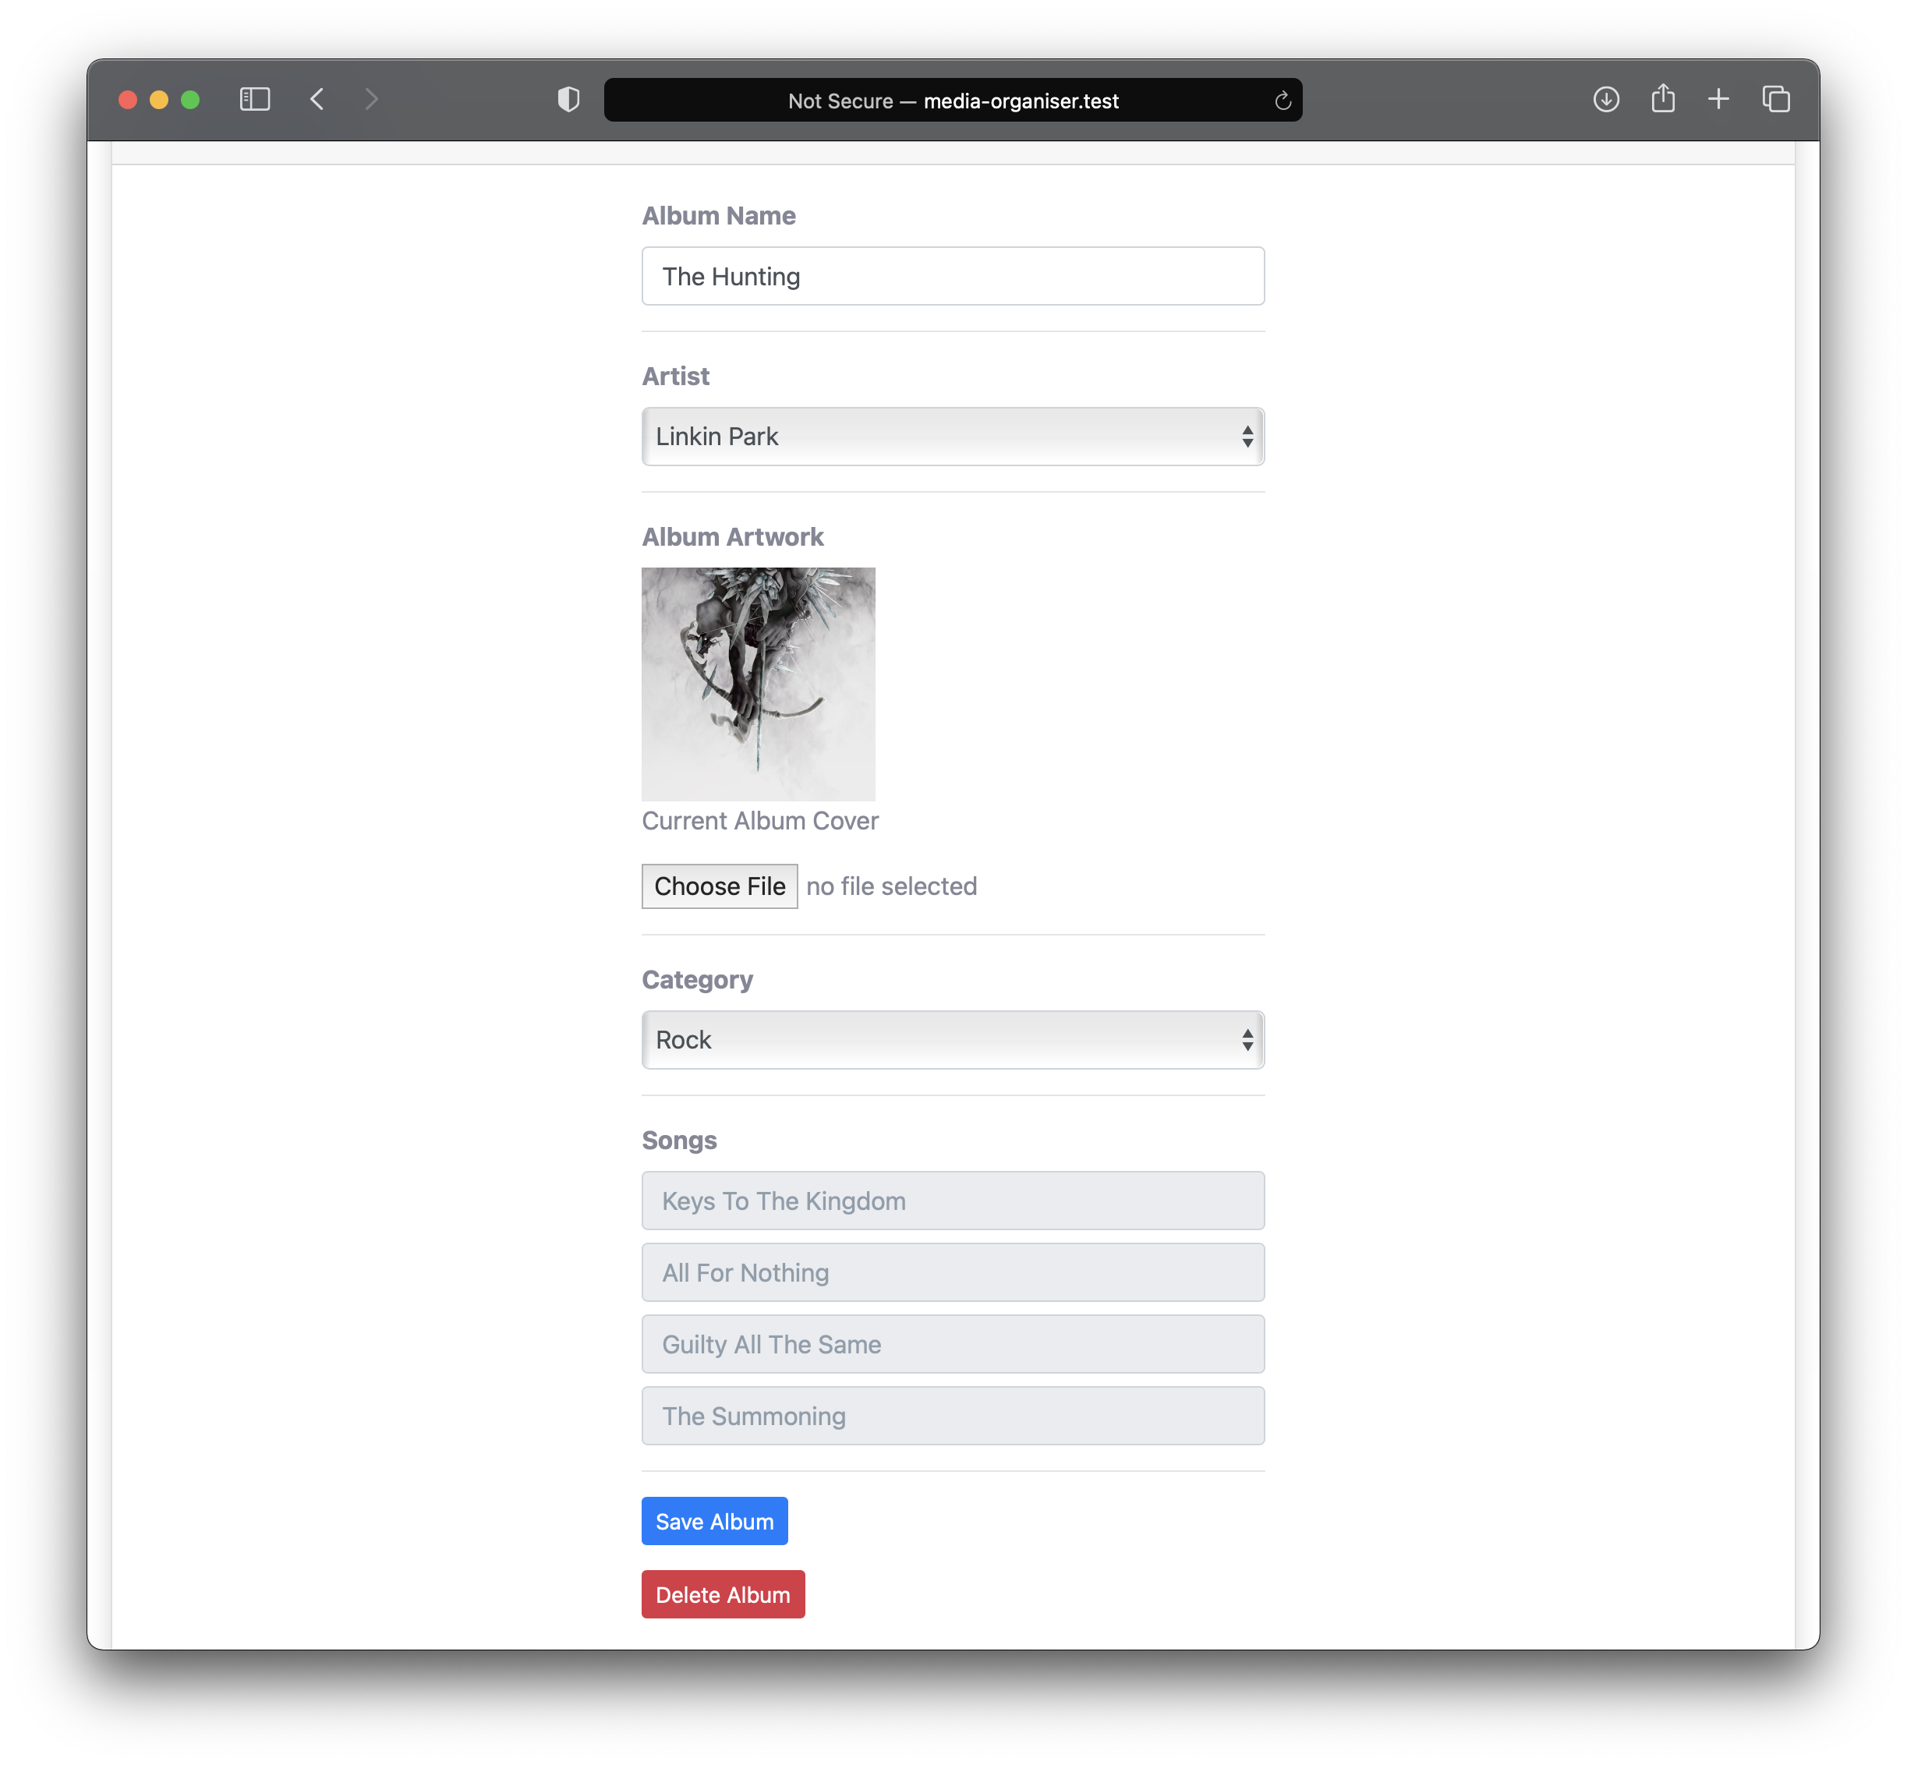

# Show Song

This page is where you can listen to the selected Song, view the Song details and view the other Songs on the same Album.

The Media Player contains the Album artwork with the Song name and the Artist name underneath, to view the Artist just click on the Artist name which will redirect you to the ‘show-artist’ page where you can view the Artist details.

The Media Controls looks a little different depending on the browser you are using, the left image shows what it looks like in the Safari browser and the right image shows what it looks like in the Chrome browser.

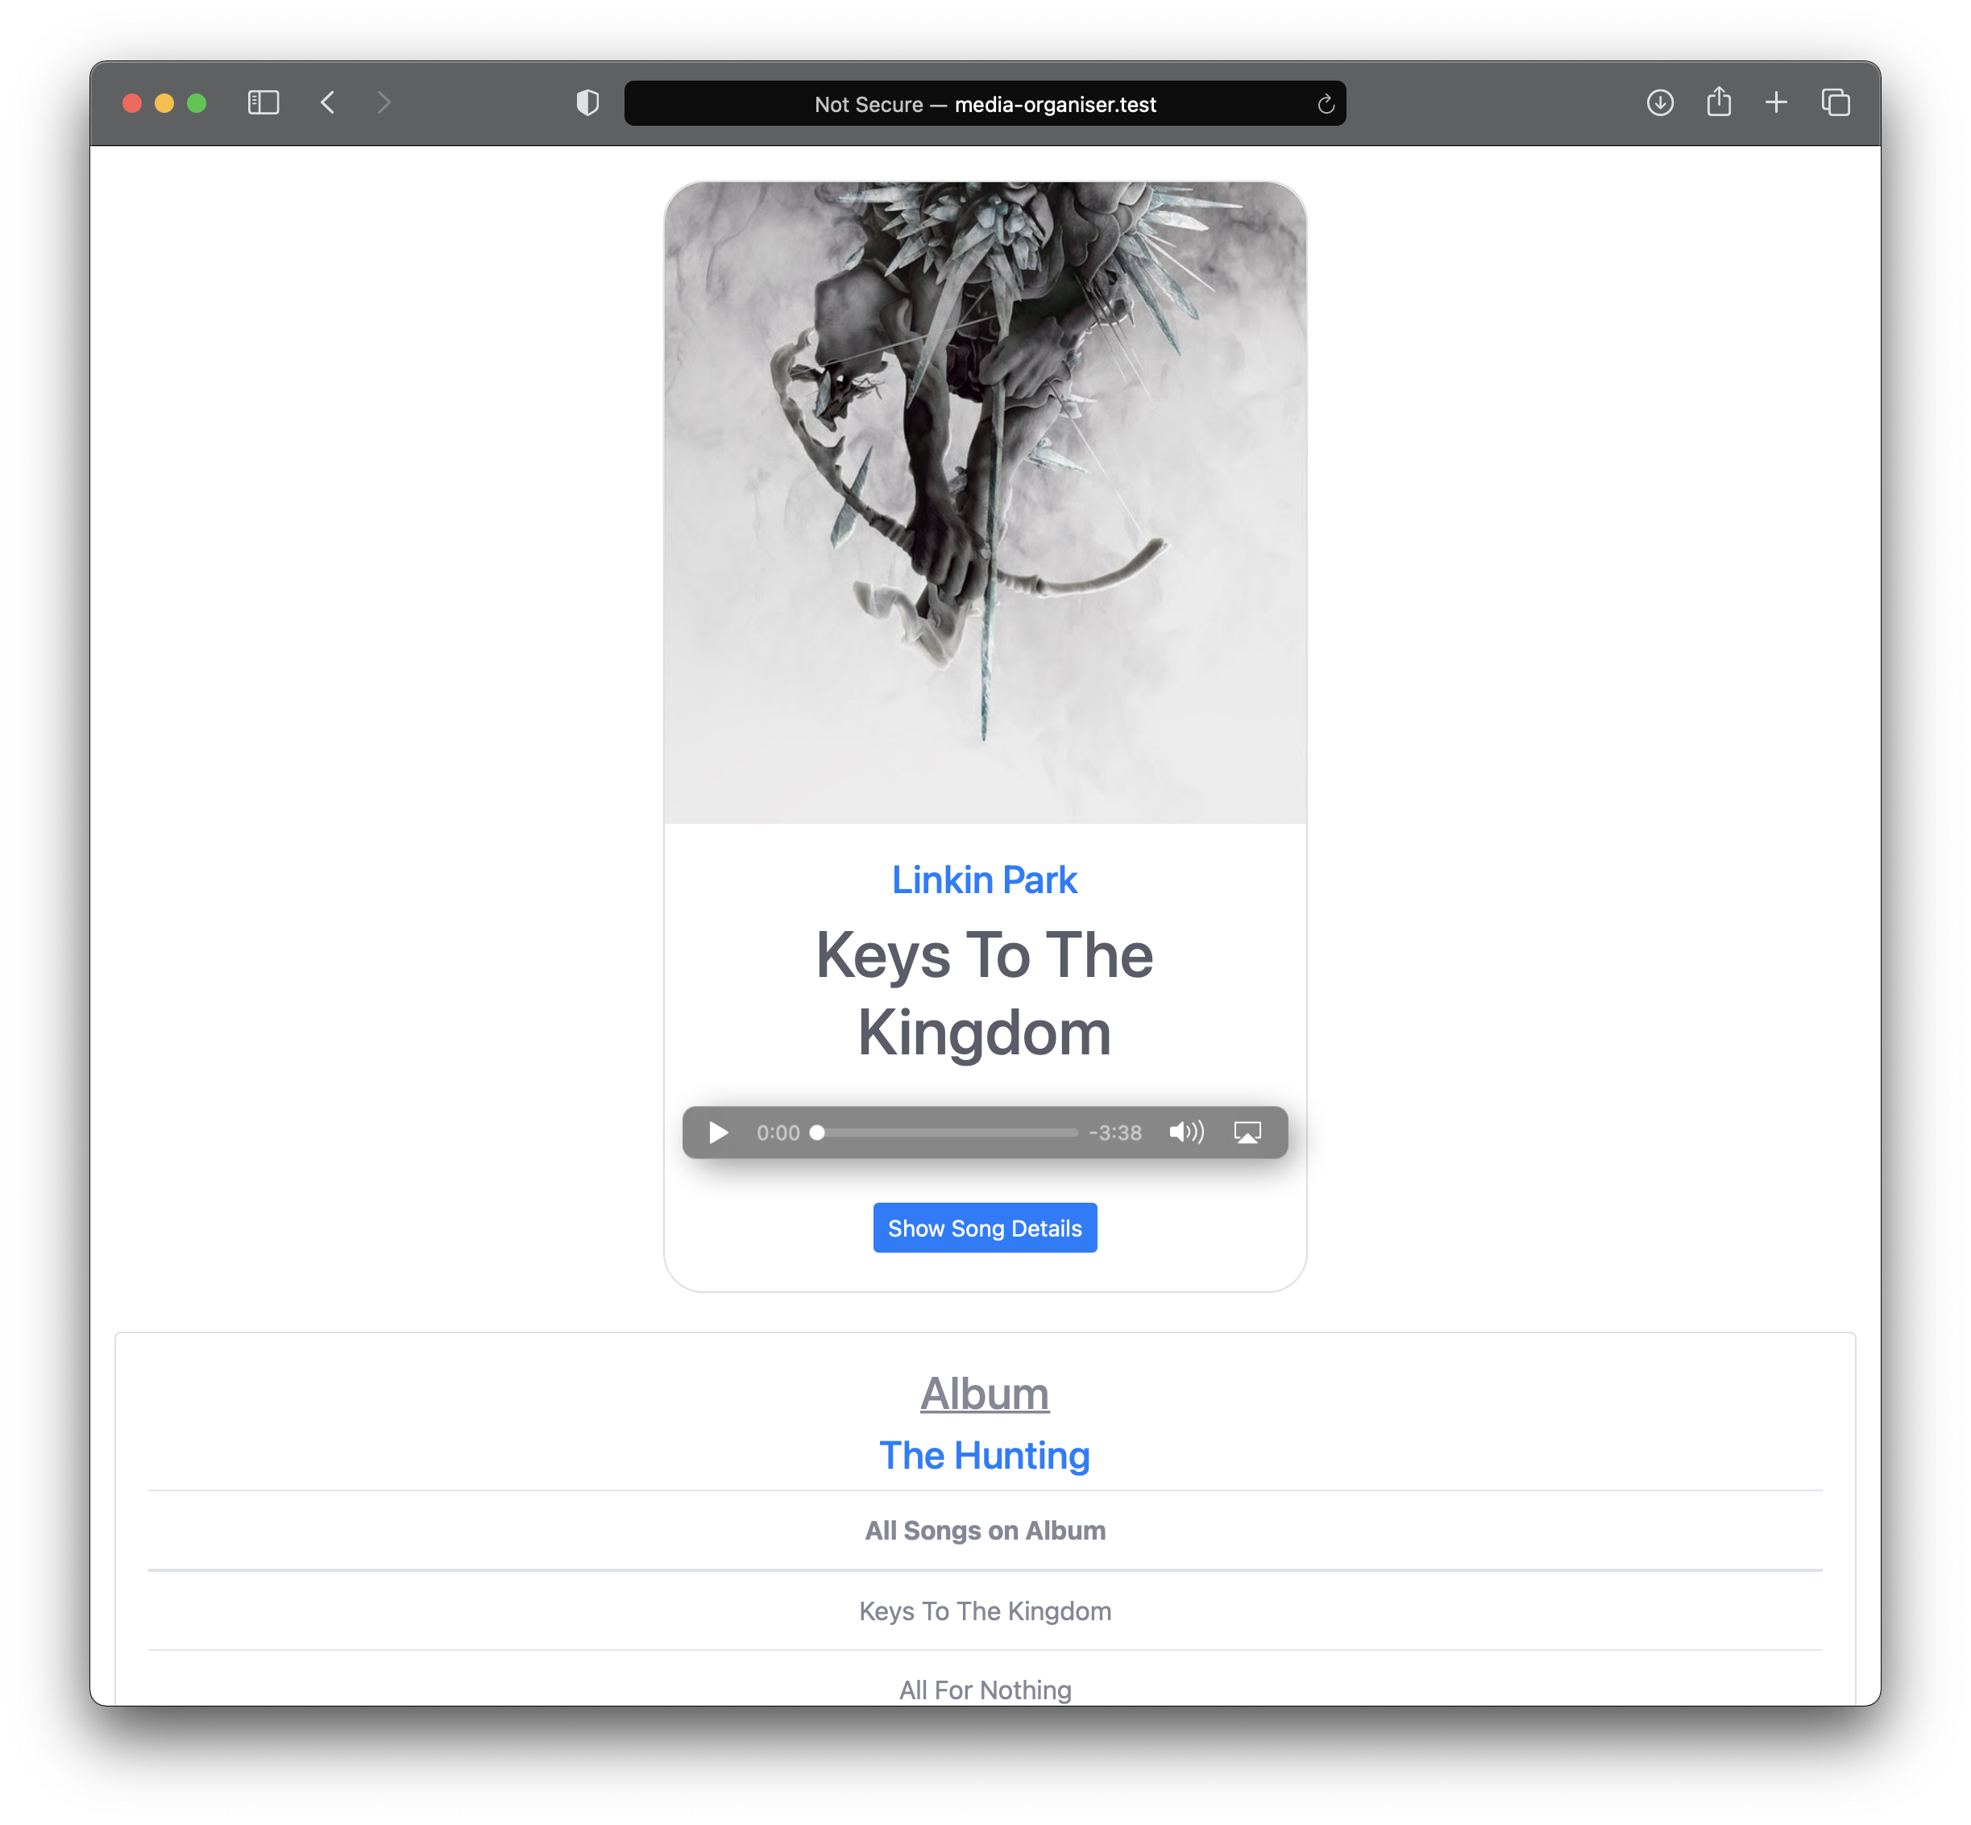

Underneath the Media Controls there is a ‘Show Song Details’ button, by clicking this button you will be presented with a pop-up box showing the Song Details including the file format, the stored location and the file size. The Song Comments can also be edited here, simply type the Comment into the ‘Comments’ input box and click on the ‘Save Comment’ button. The pop-up box can be closed by either clicking out of the pop-up box, clicking the ‘X’ at the top of the pop-up box or clicking the ‘Close’ button at the bottom of the pop-up box.

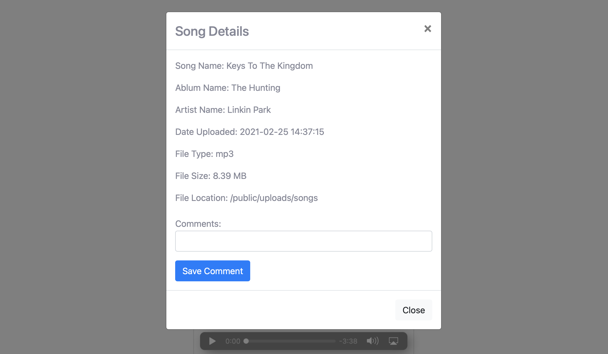

Below the Media Player you can view the Album associated with the Song, to view the Album just click on the Album name which will redirect you to the ‘show-album’ page where you can view the Album details.

You can also view the other Songs which are on the same Album, select a Song name to view the Song and the Song’s details.

# Playlists

This page shows the Playlists that have been created, if there are no Playlists then a message will be displayed saying there are no Playlists to display. If Playlists have been made you can view the Playlist by clicking the Playlist name where you will be directed to the selected Playlist to view or edit.

To add a new Playlist, click the ‘Add Playlist’ button which will direct you to the ‘add-playlist’ page.

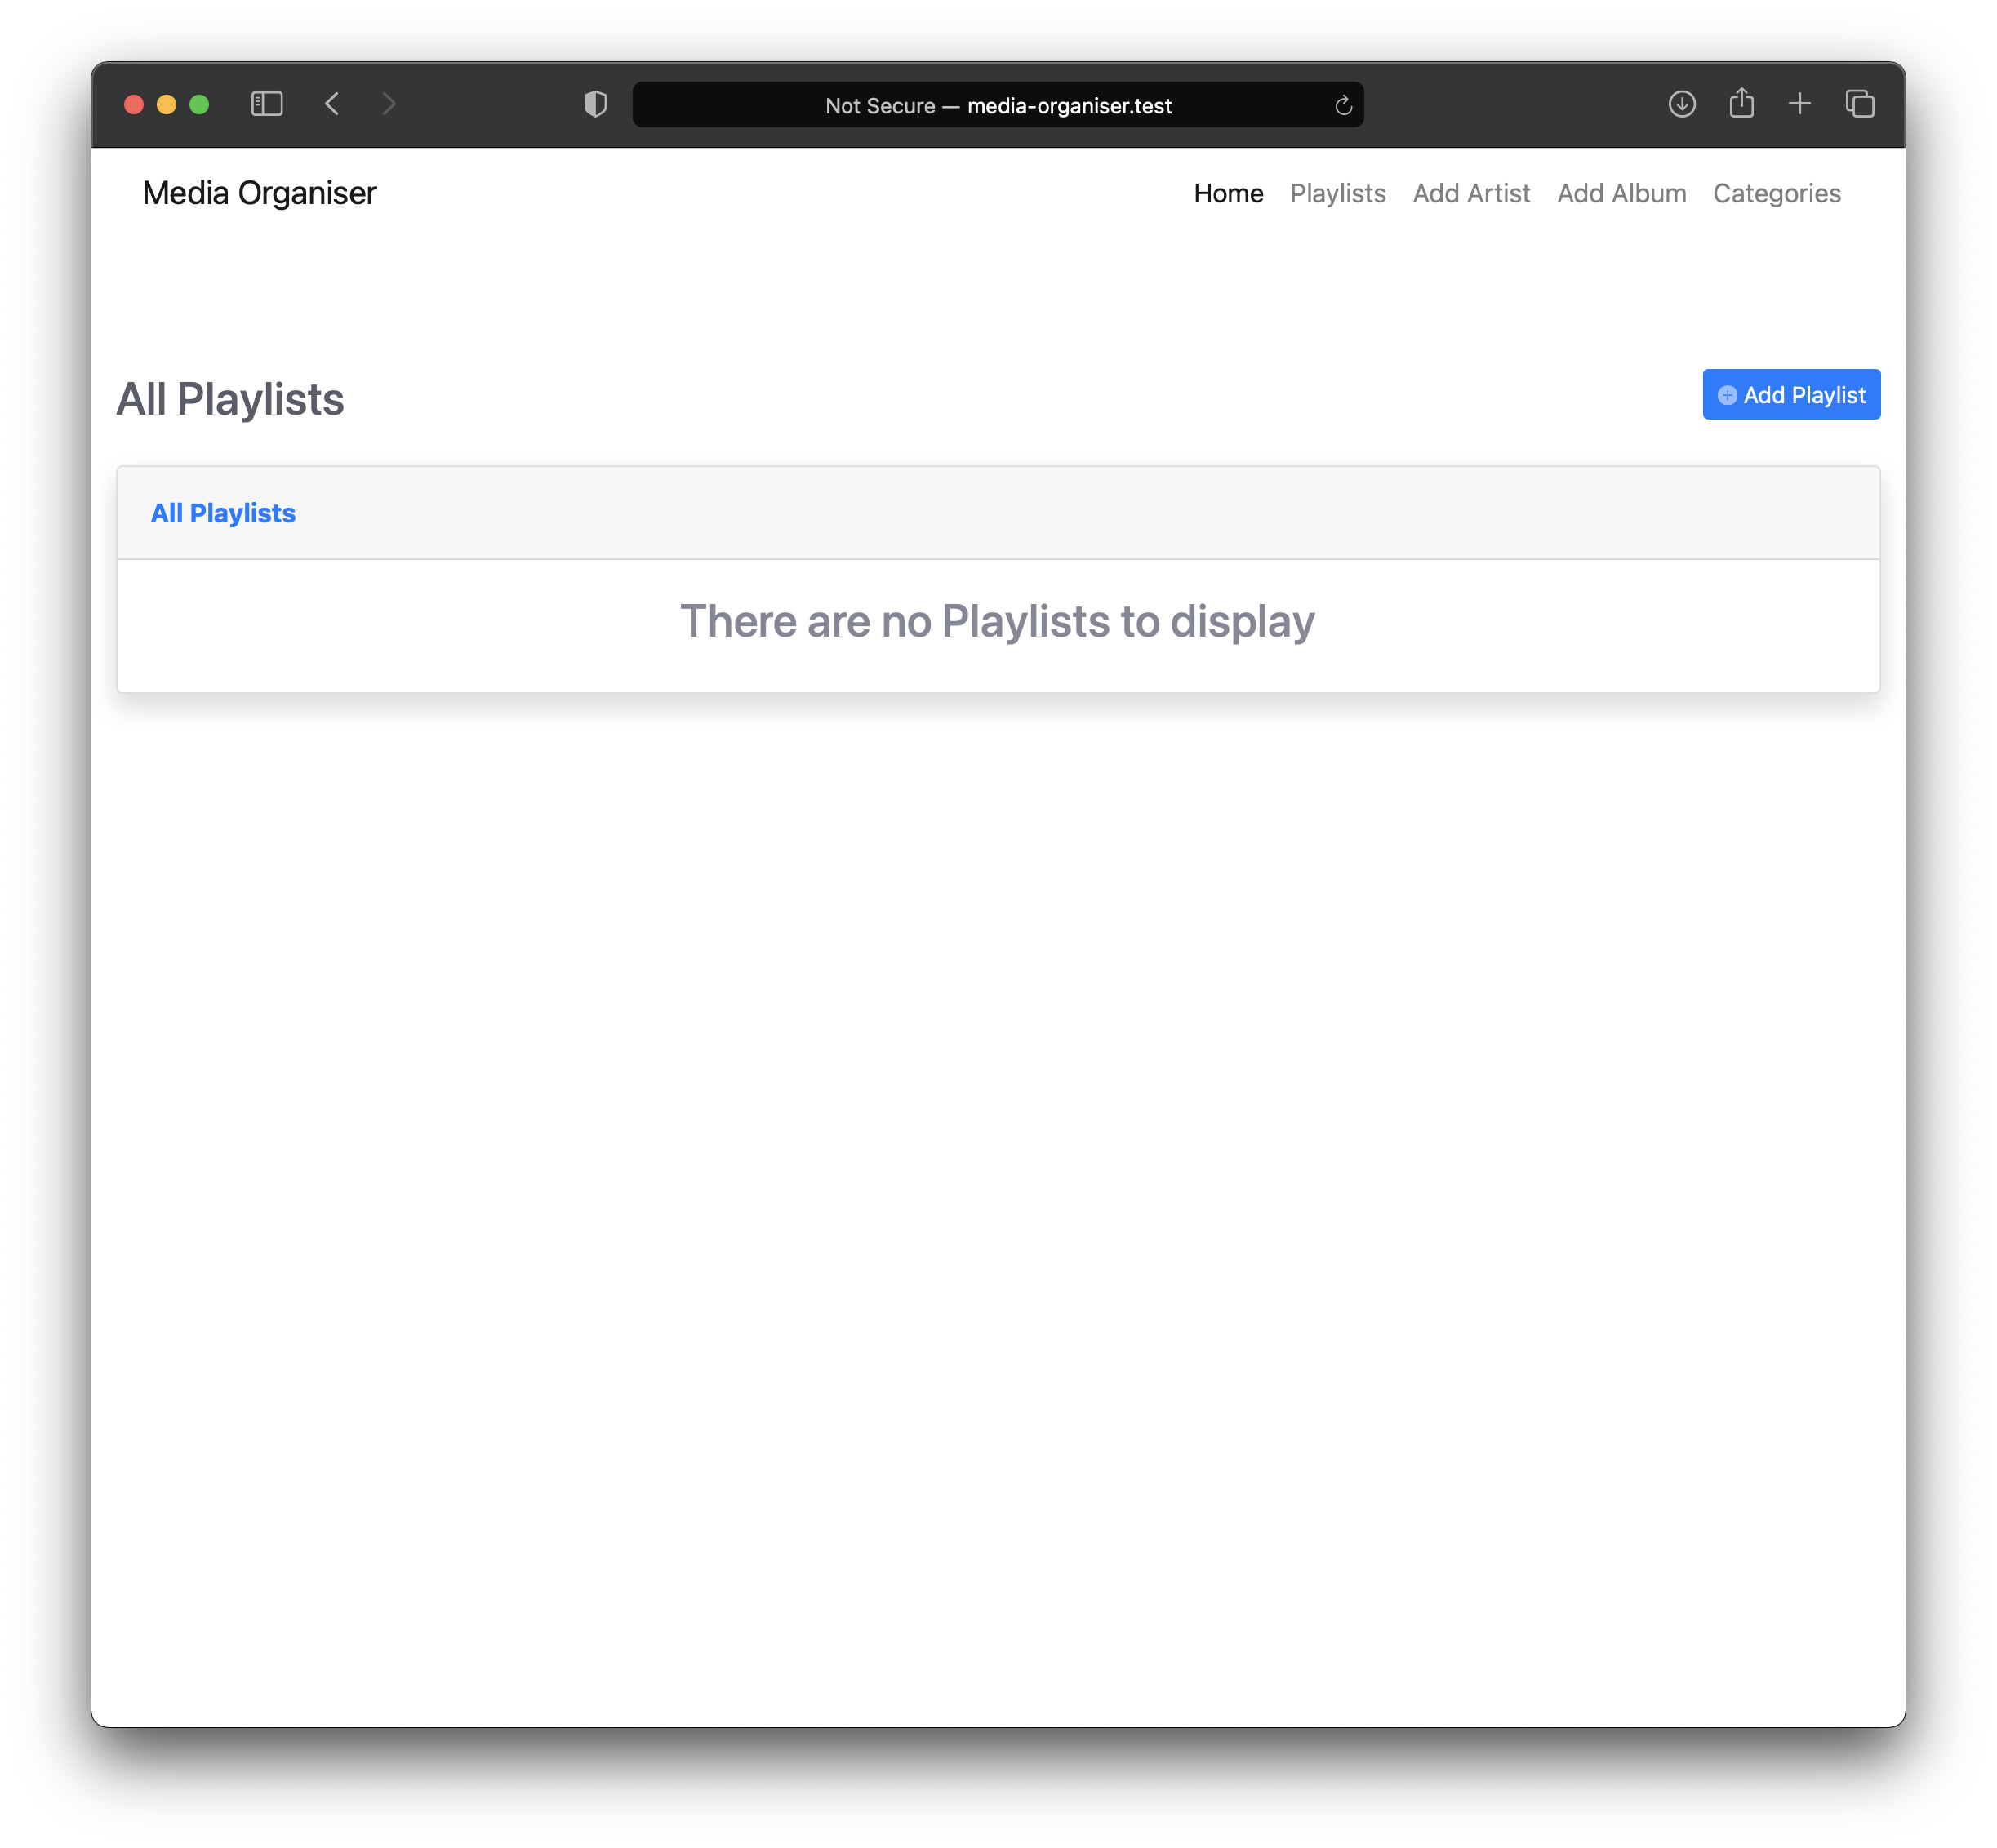

# Add Playlist

On this page you can add a new Playlist, the only mandatory input is the ‘Playlist Name’ input box.

Below the name box you will be presented with a list of all the Songs available with a toggle switch next to each name. To add a song to the Playlist select the Song toggle switches to blue.

When you have entered a Playlist name and made your selection of Songs, click the ‘Save Playlist’ button to save the Playlist. You will then be redirected to the ‘show-playlist’ page.

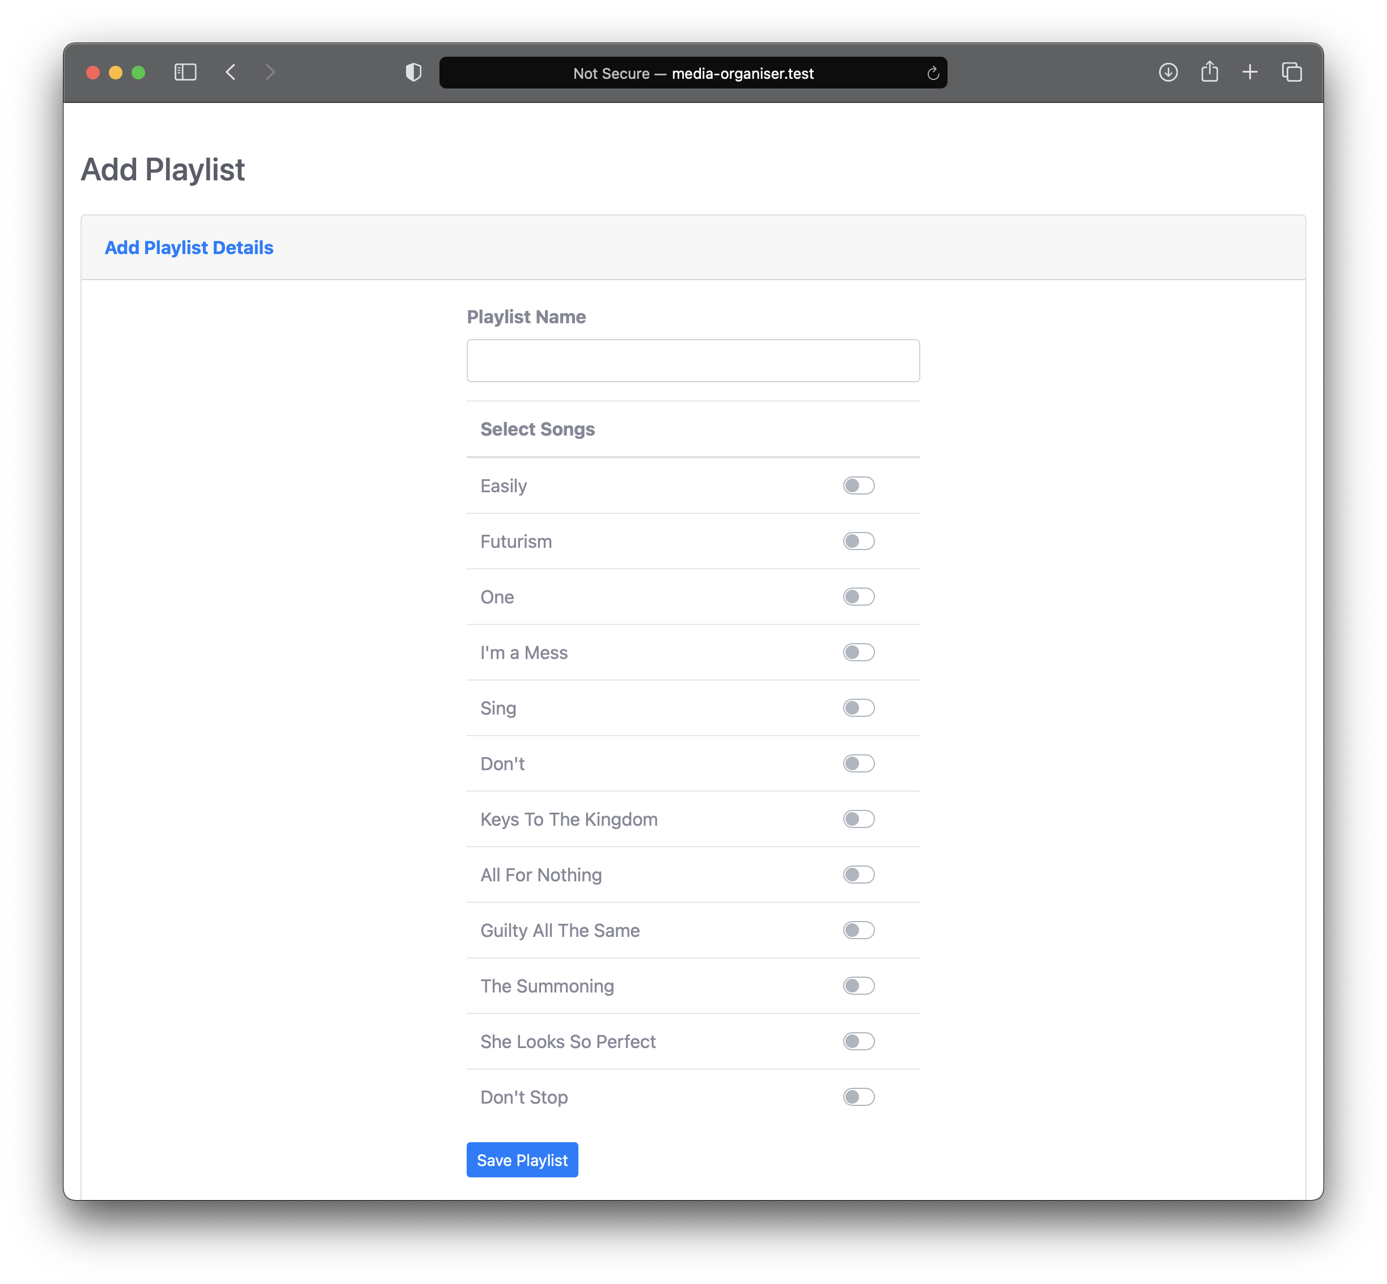

# Show Playlist

On this page you can see the Playlist name and the Songs that have been selected for the Playlist.

Under the Playlist name there is a ‘Edit Playlist’ button which will allow you to change the Playlist selection.

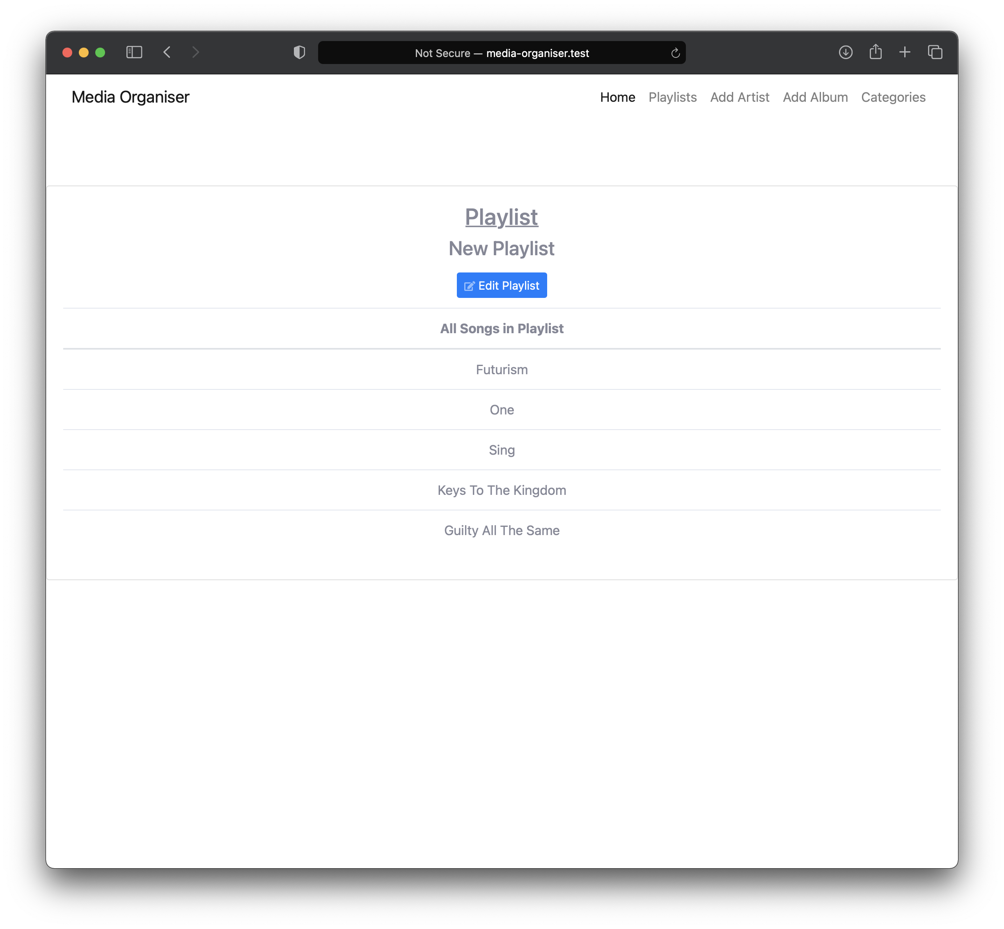

# Edit Playlist

You can make changes to the selected Playlist on this page. The ‘Playlist Name’ input box will already be filled in with the selected Playlist name and the previously selected Songs will be checked blue.

## Edit the Playlist

Check or uncheck the toggle switches to either add or remove songs from the selected Playlist, when you have made your amendments click the ‘Save Playlist’ button to save the changes and be sent back to the ‘show-playlist’ page.

## Delete the Playlist

If you want to delete the selected Playlist click the ‘Delete Playlist’ button. This will delete the Playlist. This cannot be undone once deleted.

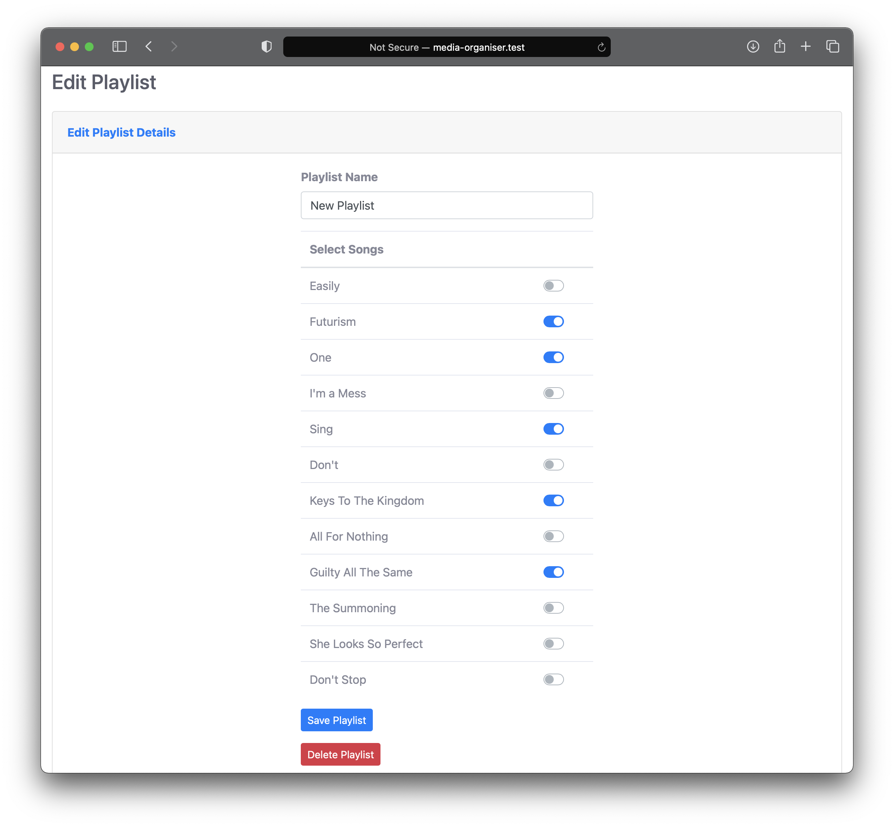

# Categories

All Categories are listed on this page. Each Category line consists of an input box for the Category name followed by a ‘Save’ button which will edit the Category name and a ‘Delete’ button that will delete the Category.

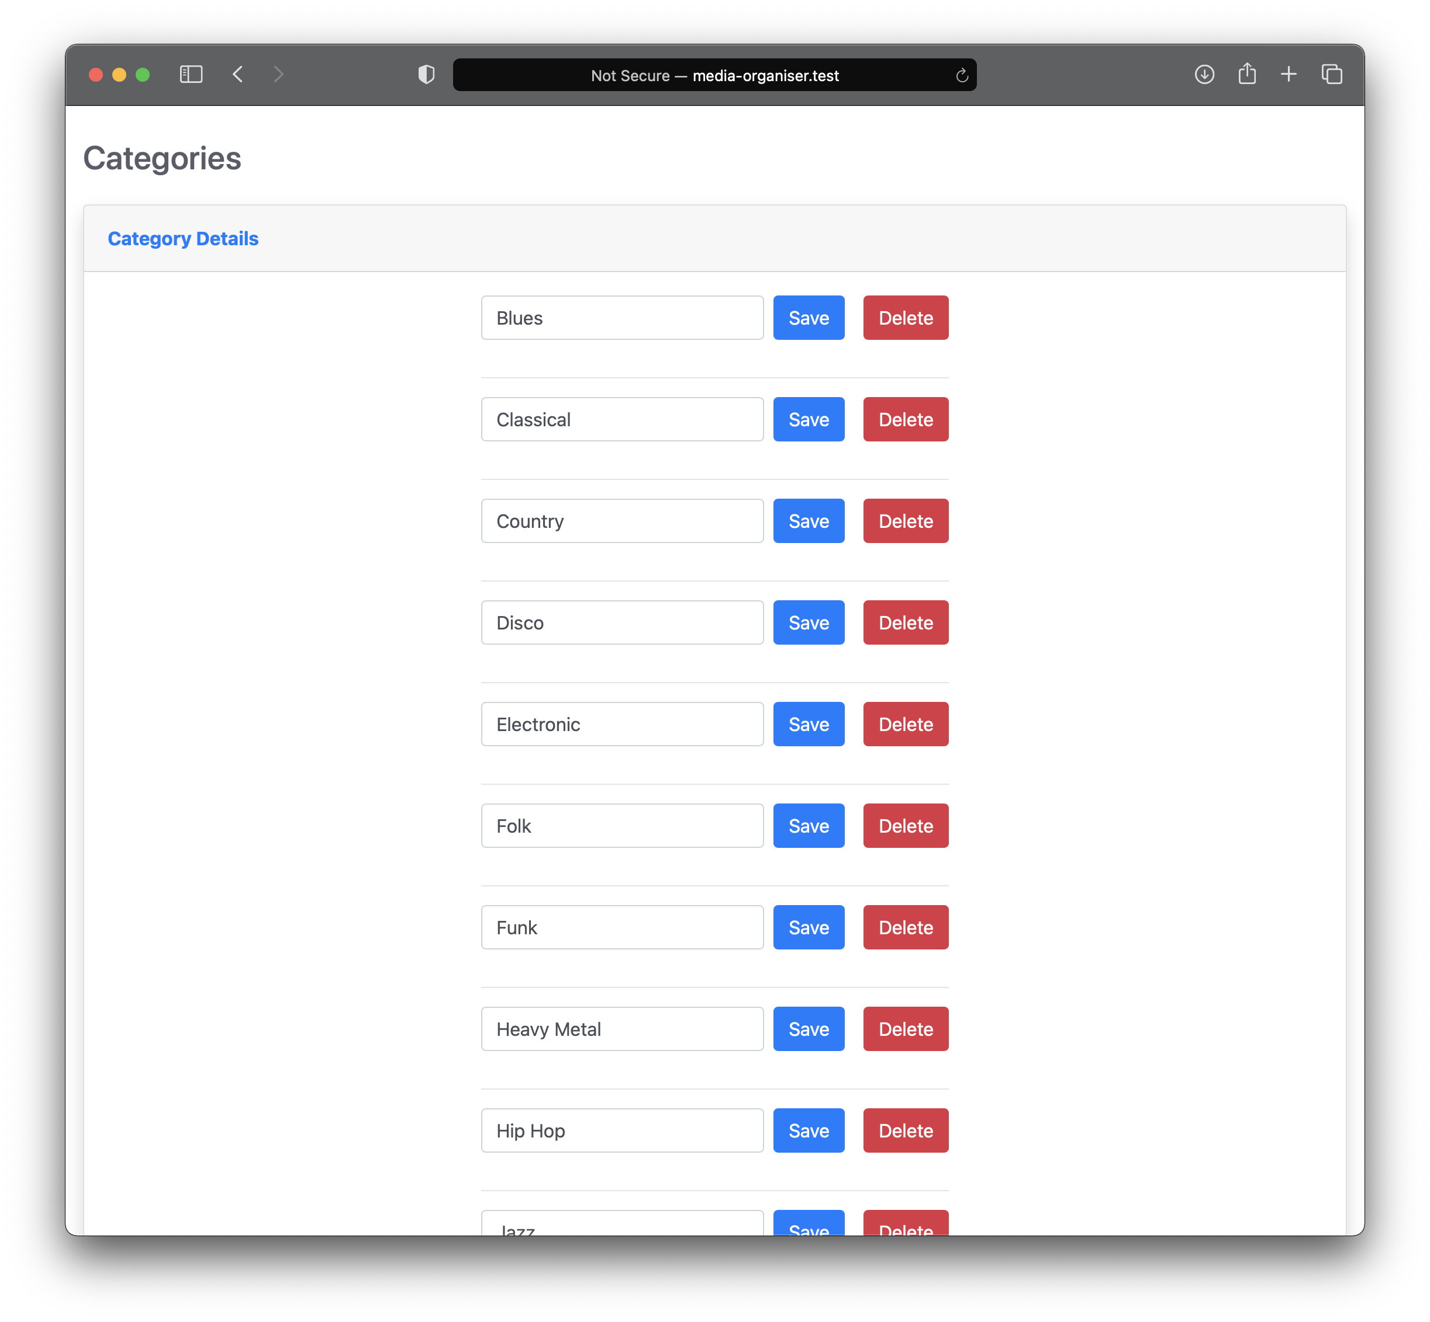

To add a new Category, scroll to the bottom of the Categories and click on the ‘Add Category’ button. You will be presented with a pop-up box. In the pop-up box is a ‘Category Name’ input box followed by two buttons.

The first is a ‘Cancel’ button which will close the pop-up box, which can also be done by clicking out of the pop-up box or clicking the ‘X’ at the top of the pop-up box.

The second is a ‘Save’ button which will save the Category name as a new Category which will be listed on the ‘categories’ page.





When making changes to the Categories, remember that this will affect the Categories displayed when adding a new Album.

# Developer Notes

The Media Organiser is currently set to use a local database as well as using local storage to function. Ensure you migrate the tables into the database before attempting to use the Media Organiser.

## Transferring into other Laravel projects

The Media Organiser can be easily integrated into other Laravel projects.

Transfer the following files to the same locations in the wider project:

Models (location – app->Models)

* Album.php
* Artist.php
* Playlist.php
* Song.php

Controllers (location – app->Http->Controllers)

* AlbumController.php
* ArtistController.php
* BackupController.php
* CategoryController.php
* PlaylistController.php

Database Tables (location – database->migrations)

* 2021_02_22_100412_create_artists_table.php
* 2021_02_22_111640_create_albums_table.php
* 2021_02_22_114856_create_songs_table.php
* 2021_02_22_120323_create_playlists_table.php
* 2021_02_22_120804_playlists_songs.php

Assets for the Public folder (location – public)

* assets (whole folder)
* uploads (whole folder)
* backups (whole folder)
* categories.xml

Views (location – resources->views)

* layouts (folder)
  + main.blade.php
  + navbar.blade.php
* add-album.blade.php
* add-artist.blade.php
* add-playlist.blade.php
* categories.blade.php
* edit-album.blade.php
* edit-artist.blade.php
* edit-playlist.blade.php
* index.blade.php
* playlists.blade.php
* show-album.blade.php
* show-artist.blade.php
* show-playlist.blade.php
* show-song.blade.php

Routes (location – routes)

* web.php (transfer the commented sections into own web.php)

## Database Migrations

To implement the tables onto the database you are using, amend the database details in the .env of your project and run the command ‘php artisan migrate’ in the terminal. If you are running a local database leave the .env data as is.

By running the ‘php artisan migrate’ command, this will transfer the database tables required for the Media Organiser to function.

## Other things to consider

When transferring the Views, you may need to amend the navbar code to suit what is required in the wider project’s navbar, alternatively, in main.blade.php just change the @include(‘layouts.navbar’) to your own navbar location.

Apart from Bootstrap, the rest of the design is located in public->assets->css->styles.css.

To change how the datatable is laid out on the main page, open database.js located in public->assets->js. For example at the moment it is set to ascending order on the third column (Artist), you can change this by changing the number under order and change where you want the column in ascending or descending order.